Management of Significant Events, Serious Incidents and Never Events Policy

Last revised | Dec 2016
Last reviewed | Jan 2018
Owner | JB

Bottom Line: if in doubt, report.

Key points:
- We encourage reporting of significant events and serious incidents.
- All reports are investigated.
- We are open and transparent with patients and carers
- We share learning from investigations with GDoc staff and – where appropriate – externally.

A note on terminology

GDoc follows the March 2015 NHS England framework for investigating Serious Incidents and Never Events: https://www.england.nhs.uk/wp-content/uploads/2015/04/serious-incidnt-framwrk-upd.pdf

The Framework defines a Serious Incident as one significant enough to “warrant using additional resources to mount a comprehensive response” – see Appendix 1.

However, the Framework also encourages providers to have a low threshold for investigating all adverse and potentially adverse incidents, even if they do not meet the criteria of a Serious Incident. Most adverse and potentially adverse incidents experienced by GDoc do not meet the criteria of a Serious Incident in the NHSE Framework. GDoc investigates all incidents for the purposes of service improvement and learning. Where an incident does meet the criteria for a Serious Incident, GDoc will follow the process laid down in the Framework.

For brevity, “incident” is used in this document to mean any adverse or potentially adverse incident, whether or not if meets the criteria of a Serious Incident in the 2015 Framework.
A significant event is a positive or negative event that can be used for learning and quality improvement. There is no mandatory requirement for organisations to report or investigate significant events in a specific way, although those that are also serious incidents should be managed accordingly. The emphasis for significant events is personal and organisational reflection and learning.
Principles of Incident Management
When a report of an incident is received, GDoc will:

- Take any immediate remedial actions needed
- Investigate why it happened
- Report externally if appropriate
- Inform the patient, including providing an apology where appropriate
- Ensure any actions and learning from the incident are implemented

How Staff Can Report:
- Use the desktop icon for ‘one click’ easy reporting
- By email to the GDoc office
- By phone to the GDoc office.

Process once a report is received
- If the incident may have had an impact on clinical care, the clinical lead and nursing lead are informed.
- A decision is made as to whether the incident meets the criteria for a Serious Incident or Never Event as laid down in the 2015 NHSE Framework. (If a decision is made that the incident does not meet these criteria, this will be revisited if, during the investigation, further information comes to light that suggests the criteria may have in fact been met.)
- The lead investigator and clinical/nursing leads agree the appropriate form of investigation and who should lead it. If the criteria for a Serious Incident are met, this decision will be based on the NHSE Framework guidance [see Appendix 3].
- External reporting is performed if appropriate (see below)
- The investigation is undertaken, remedial action and learning for the organisation are identified.
- Where relevant, the patient (or carer) is informed and an apology given, in keeping with the Duty of Candour.
- Feedback is given to the incident reporter
- The incident is discussed at the next clinical governance meeting and at the annual trends analysis clinical governance meeting.
- Learning is shared with the GDoc team and, where relevant, partner organisations, for example a Choice Plus host site.

External Reporting
- If the incident meets the threshold for external reporting, this is undertaken by the clinical lead, following the process laid out in the 2015 NHSE Framework [see Appendix 2]. In the absence of the clinical lead, the business lead will undertake reporting, supported by the GP directors.
- Where appropriate, RIDDOR reportable events [see Appendix 4] will be reported to the Health & Safety Executive by the Business Lead or her deputy.

Appendix 1: What is a Serious Incident?

The excerpts below are from the 2015 NHS England Framework https://www.england.nhs.uk/wp-content/uploads/2015/04/serious-incidnt-framwrk-upd.pdf.

What is a Serious Incident?
In broad terms, serious incidents are events in health care where the potential for learning is so great, or the consequences to patients, families and carers, staff or organisations are so significant, that they warrant using additional resources to mount a comprehensive response. Serious incidents can extend beyond incidents which affect patients directly and include incidents which may indirectly impact patient safety or an organisation’s ability to deliver ongoing healthcare. …

There is no definitive list of events/incidents that constitute a serious incident and lists should not be created locally as this can lead to inconsistent or inappropriate management of incidents….
.
The definition below sets out circumstances in which a serious incident must be declared. Every incident must be considered on a case-by-case basis using the description below. Inevitably, there will be borderline cases that rely on the judgement of the people involved..
Serious Incidents in the NHS include:

- Acts and/or omissions occurring as part of NHS-funded healthcare (including in the community) that result in:

- Unexpected or avoidable death of one or more people. This includes
- suicide/self-inflicted death; and
- homicide by a person in receipt of mental health care within the recent past

- Unexpected or avoidable injury to one or more people that has resulted in serious harm;

- Unexpected or avoidable injury to one or more people that requires further treatment by a healthcare professional in order to prevent:—
- the death of the service user; or
- serious harm;

- Actual or alleged abuse; sexual abuse, physical or psychological ill- treatment, or acts of omission which constitute neglect, exploitation, financial or material abuse, discriminative and organisational abuse, self- neglect, domestic abuse, human trafficking and modern day slavery where:
- healthcare did not take appropriate action/intervention to safeguard against such abuse occurring; or
- where abuse occurred during the provision of NHS-funded care.
This includes abuse that resulted in (or was identified through) a Serious Case Review (SCR), Safeguarding Adult Review (SAR), Safeguarding Adult Enquiry or other externally-led investigation, where delivery of NHS funded care caused/contributed towards the incident

- A Never Event - all Never Events are defined as serious incidents although not all Never Events necessarily result in serious harm or death.

Appendix 2: Overview of Serious Incident Management
From the NHS England Framework 2015

Note: Serious Incident in this diagram refers to Serious Incidents that meet the thresholds laid out in the Framework.

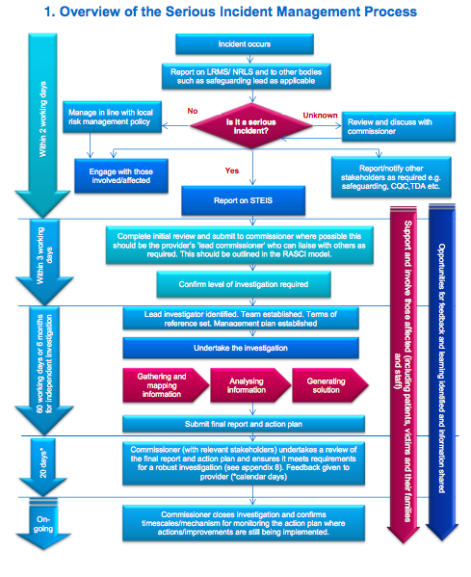

Appendix 3: Levels of Investigation of Serious Incidents
From the NHS England Framework 2015

Note: Serious Incident in this diagram refers to Serious Incidents that meet the thresholds laid out in the Framework.

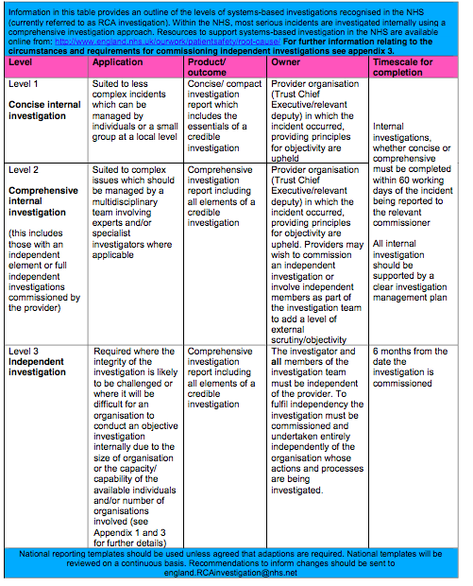

Appendix 4: Reportable Incidents under RIDDOR 2013
From The Reporting of Injuries, Diseases and Dangerous Occurrences Regulations 2013

The death of any person
All deaths to workers and non-workers, with the exception of suicides, must be reported if they arise from a work-related accident, including an act of physical violence to a worker.

Specified injuries to workers
The list of ‘specified injuries’ in RIDDOR 2013 replaces the previous list of ‘major injuries’ in RIDDOR 1995. Specified injuries are (regulation 4):

- fractures, other than to fingers, thumbs and toes
- amputations
- any injury likely to lead to permanent loss of sight or reduction in sight
- any crush injury to the head or torso causing damage to the brain or internal organs
- serious burns (including scalding) which:
- covers more than 10% of the body
- causes significant damage to the eyes, respiratory system or other vital organs
- any scalping requiring hospital treatment
- any loss of consciousness caused by head injury or asphyxia
- any other injury arising from working in an enclosed space which:
- leads to hypothermia or heat-induced illness
- requires resuscitation or admittance to hospital for more than 24 hours

Over-seven-day incapacitation of a worker
Accidents must be reported where they result in an employee or self-employed person being away from work, or unable to perform their normal work duties, for more than seven consecutive days as the result of their injury. This seven day period does not include the day of the accident, but does include weekends and rest days. The report must be made within 15 days of the accident.

Over-three-day incapacitation
Accidents must be recorded, but not reported where they result in a worker being incapacitated for more than three consecutive days. If you are an employer, who must keep an accident book under the Social Security (Claims and Payments) Regulations 1979, that record will be enough.

Non fatal accidents to non-workers (eg members of the public)
Accidents to members of the public or others who are not at work must be reported if they result in an injury and the person is taken directly from the scene of the accident to hospital for treatment to that injury. Examinations and diagnostic tests do not constitute ‘treatment’ in such circumstances.

There is no need to report incidents where people are taken to hospital purely as a precaution when no injury is apparent.

If the accident occurred at a hospital, the report only needs to be made if the injury is a ‘specified injury’ (see above).

Occupational diseases
Employers and self-employed people must report diagnoses of certain occupational diseases, where these are likely to have been caused or made worse by their work: These diseases include (regulations 8 and 9):

- carpal tunnel syndrome;
- severe cramp of the hand or forearm;
- occupational dermatitis;
- hand-arm vibration syndrome;
- occupational asthma;
- tendonitis or tenosynovitis of the hand or forearm;
- any occupational cancer;
- any disease attributed to an occupational exposure to a biological agent

See http://www.hse.gov.uk/riddor/index.htm for further guidance.

