How to change the GP configuration on SystmOne to GPs working in Cheltenham Clusters
The GP often rings to say “ My screen doesn’t look correct, or this button is greyed out and I can’t access something”
- Setup
- Users & policy
- Organisation preferences
- Expand Clinical policy
- Tree configuration
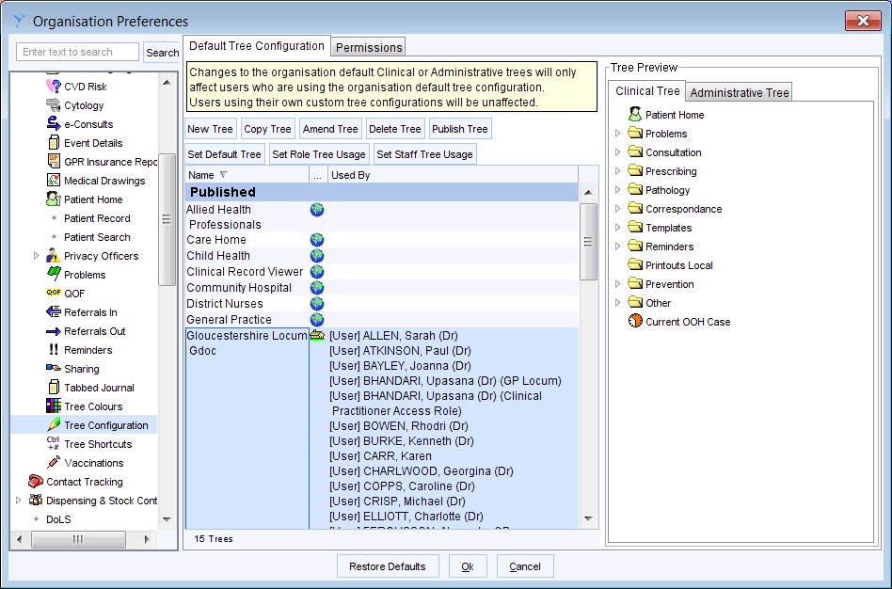

- Select Gloucestershire Locum GDoc (as highlighted above)
- Click ‘Set Staff Tree Usage’
- Select the GP you are looking for
- Select the and ok
- Refer back to the bottom of the preferences on the left hand side and find Toolbar
- Select Gloucestershire Locum GDoc (as highlighted above)
- Set Staff Toolbar Usage
- Select the GP you are looking for
- Select the and ok
- END

