- URL - https://portal.nfon.com/login
- Username - KB14J
- Password - z7Tak322EE*
The Time Control Service sets the time that the on-call divert is effective from.
Pencil symbol to edit – change the time for a Friday when all leave office at 4pm
Change time and save. 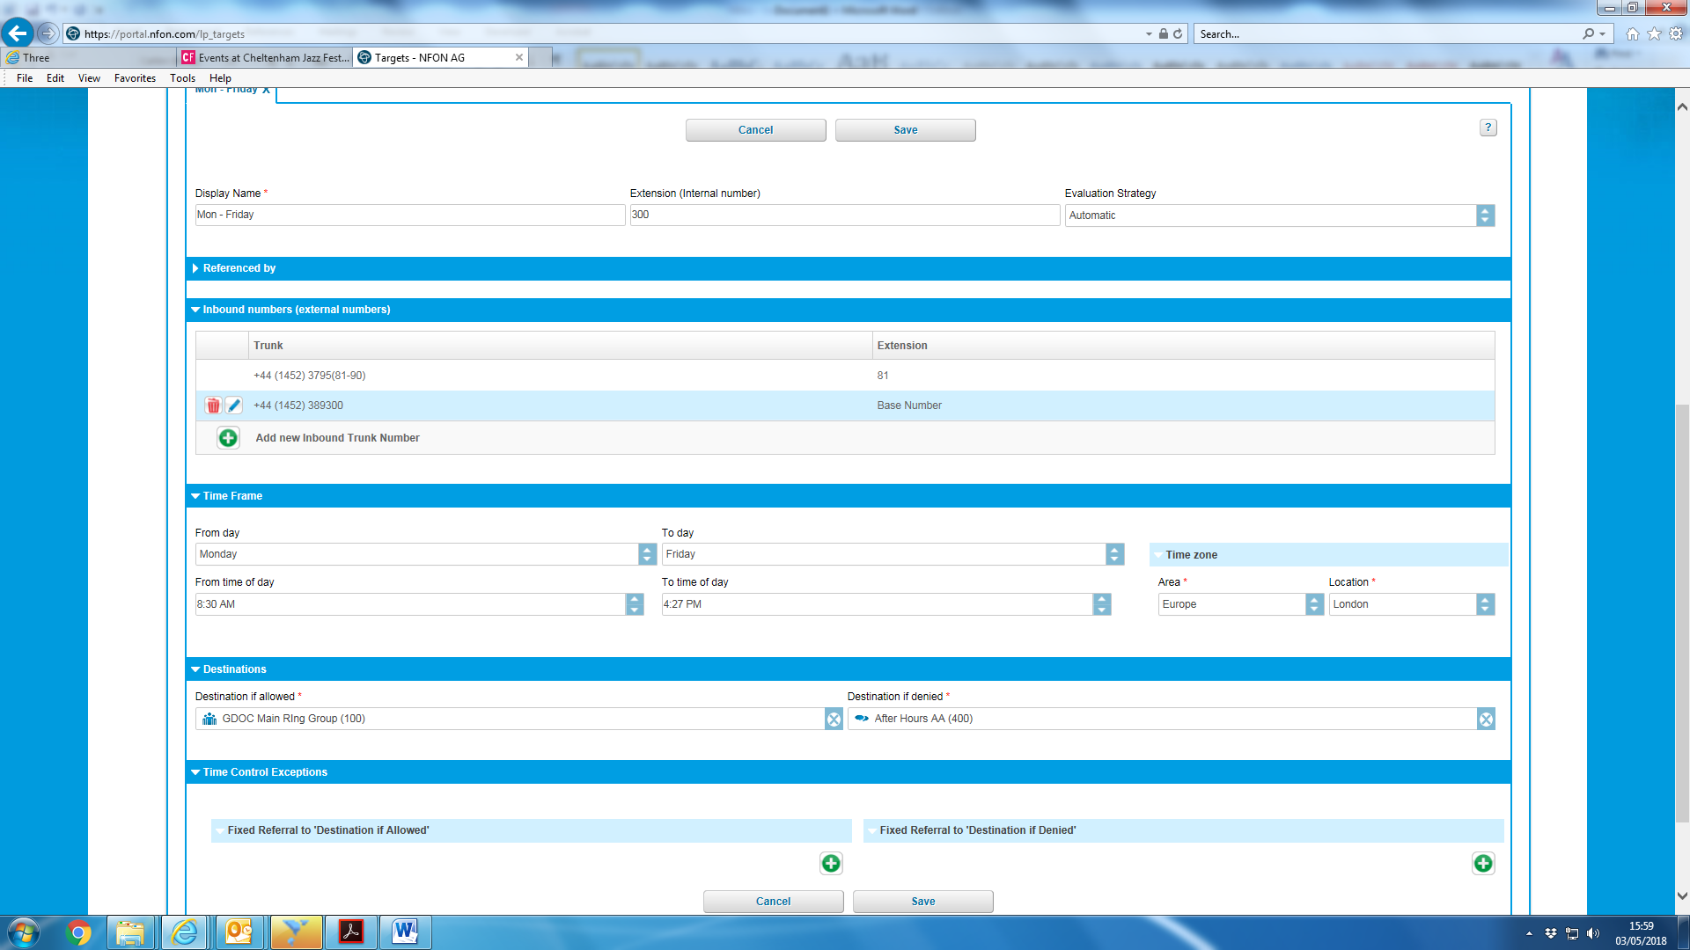

To change the on-call phone number - select IVR Service - edit.
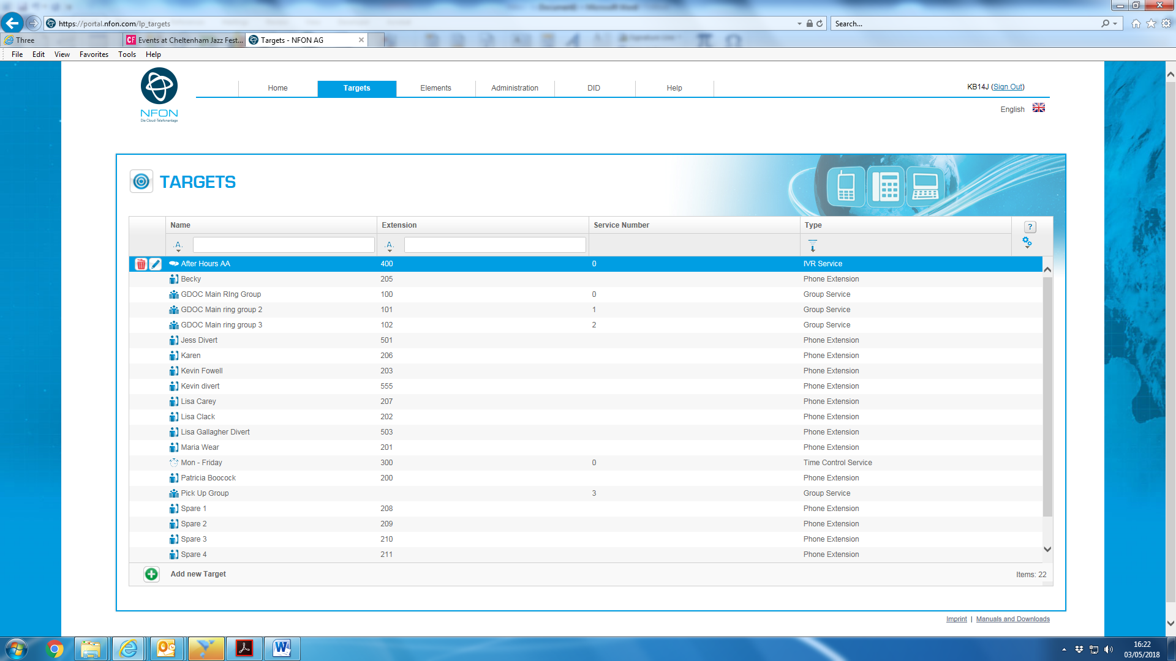
Under Key Assignments - Edit to set new individual.
Choose new contact from drop-down list. Type 5 to select
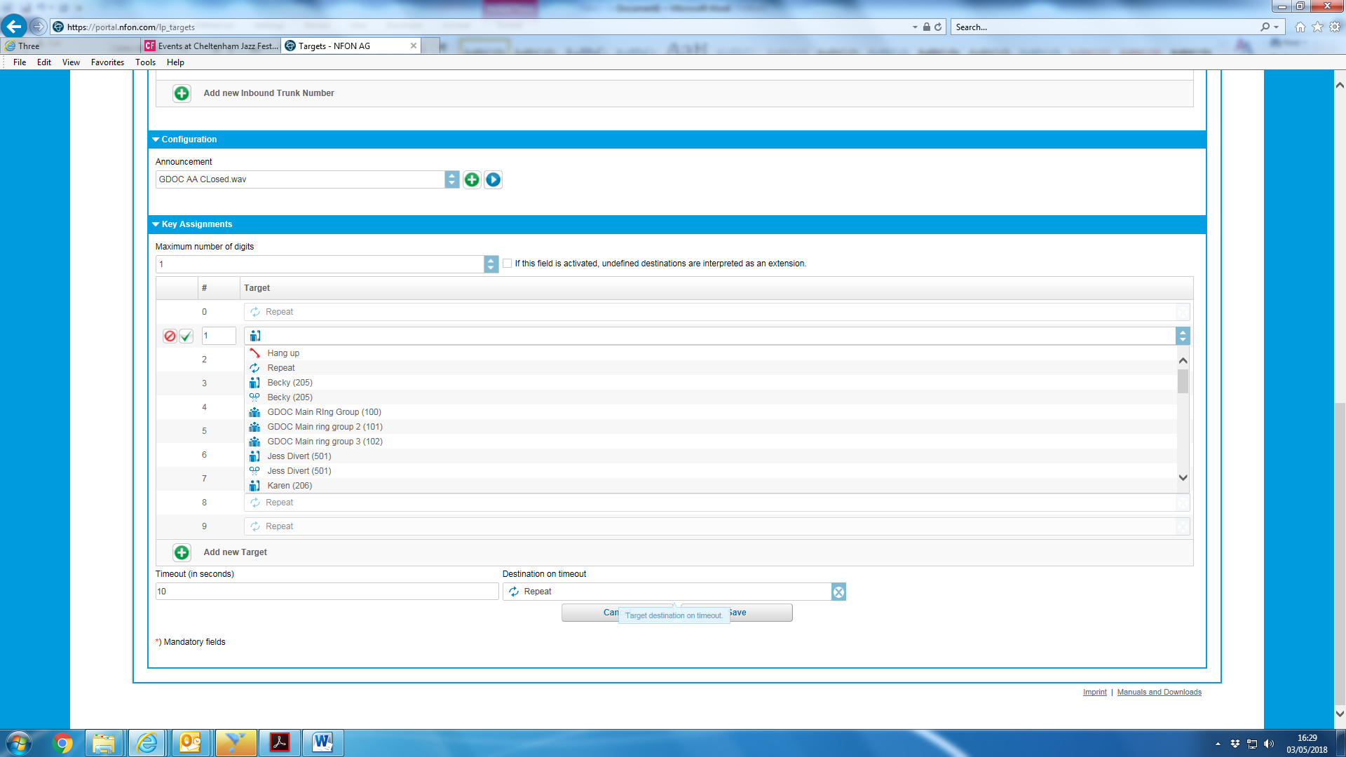

Select the new individual – green tick – and save.
Then Sign out

