HOW TO ADD / AMEND / DELETE A SESSION

Log in to and open SystmOne (See Logon.docx)

If you are processing notifications from / in RotaCloud,
Log in to and open RotaCloud (See..\RotaCloud\Admin How To Guides\Logon.docx)

However, if you are dealing with notifications from RotaCloud in
your Outlook account there is no need to open RotaCloud in
most instances, the exception being “Unavailability Requests”

Your screen will open on today’s date but, for reasons of
confidentiality, in this working aid we are using a future date

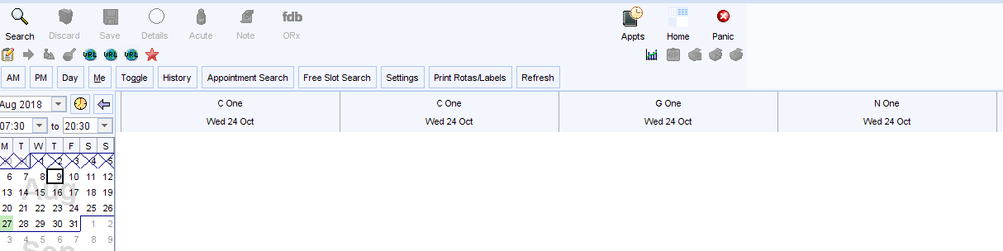

To ADD the relevant session

If there are no sessions already listed for the date you require:

Select “Only staff with rotas”

This will then display all staff across the top of the page

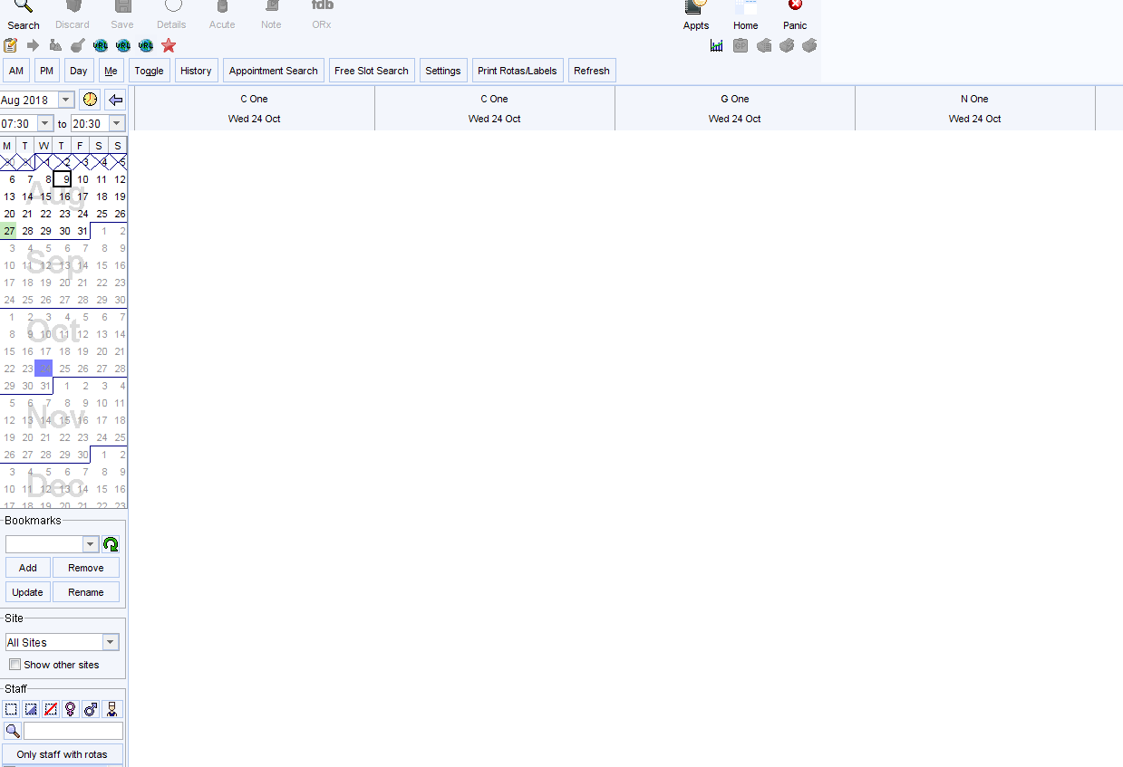

Scroll across the staff members until you find the person you need
Right click into the white space beneath the staff member’s name
Select “Apply Rota Template”

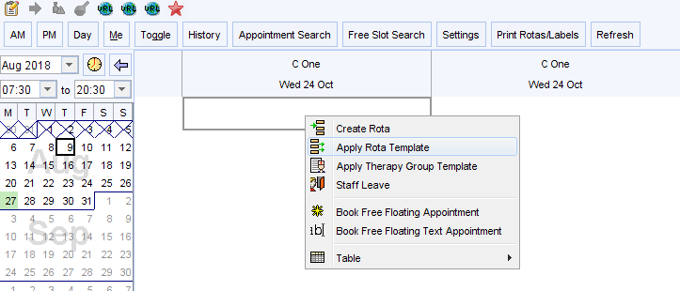

As you will see, the GP’s name is already displayed in
“Apply template for”

From the “at” dropdown, select the relevant template

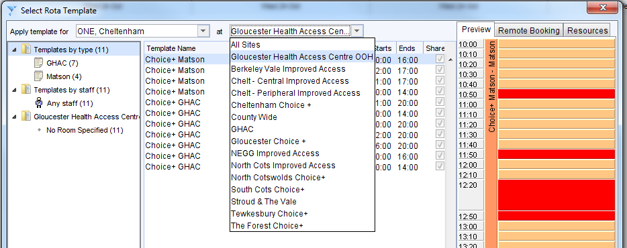

Double click on the template you require

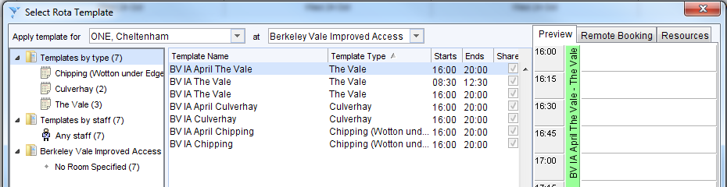

The relevant template is then displayed

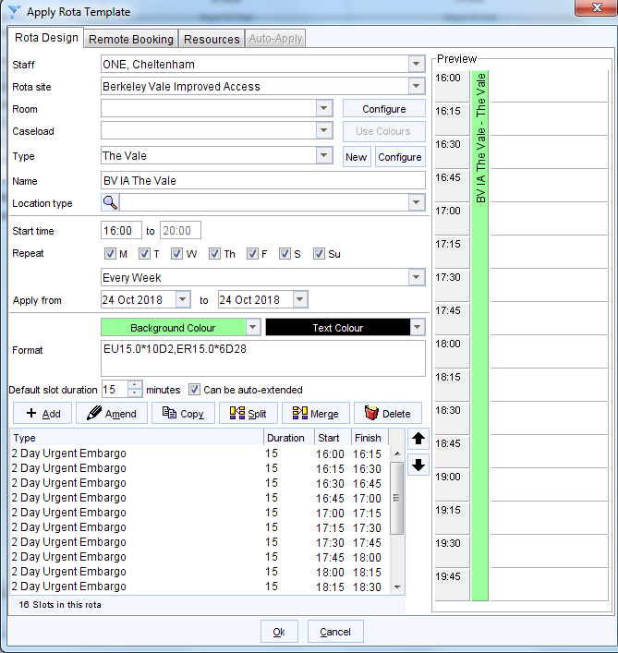

Select the “Start time” and change it to match the end time
(e.g. for a 4 to 8 p.m. session : change 16:00 to read 20:00)
Click “OK”

Right click in the coloured banner at the top of the session (these vary in colour)

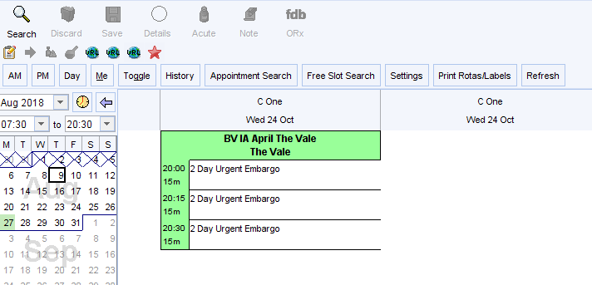

Select “Administration” / “Change time / date”

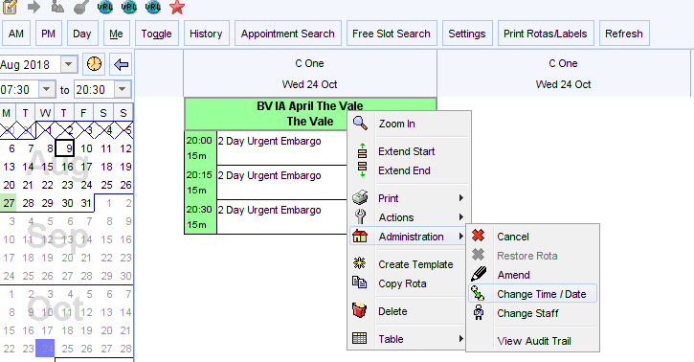

Change “Time” back to the appropriate start time (e.g.16:00)
Click “OK”

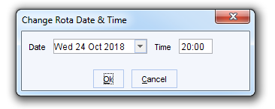

All appointment times are then displayed for the session

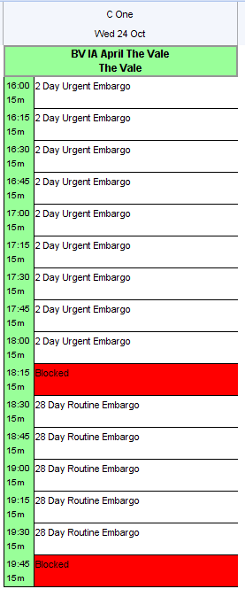

The reason for changing the times is because SystmOne does not always
recognise all the relevant “Remote Bookings” but something in the
system is triggered when we change the times as above

If there are sessions already listed for the date you require:

Scroll across the screen to see if the staff member already has another shift Claimed for the same date. If so, you can right click in the white space beneath their allotted session and then follow the procedure above provided times do not clash. For what to do in the case of a time clash or for other necessary amendments, see either “Amend a Session” below or

If the staff member does not already have a session listed for the relevant date,
scroll across the screen until you are near to another member of staff whose last name starts with the same or a nearby letter of the alphabet. Right click in the white space beneath one of those names and follow the procedure above. BUT IN THIS INSTANCE you will need to select the appropriate staff member from the “Apply rota for” dropdown when you are applying the template

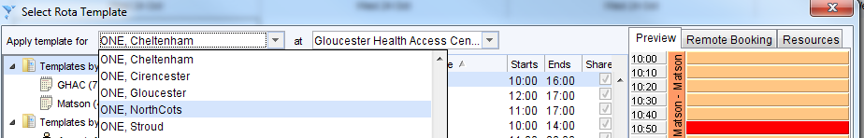

To AMEND a session

Right click in the coloured banner at the top of the session

Select “Administration” / “Amend”

In this example we will assume that we need to change a particular appointment

Highlight the appointment you need to change
Select “Amend” ( )
From the “Type” dropdown, select the appropriate amendment
(in this instance we will change from an urgent to a routine appointment)
If appropriate, change the number of days for the “Embargo duration”
Click “OK”

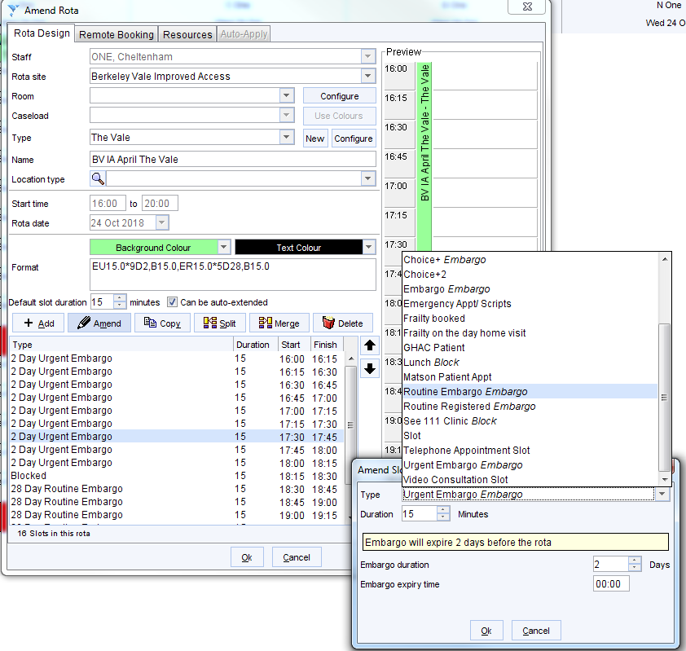

Click “OK” at the foot of the “Amend Rota” window

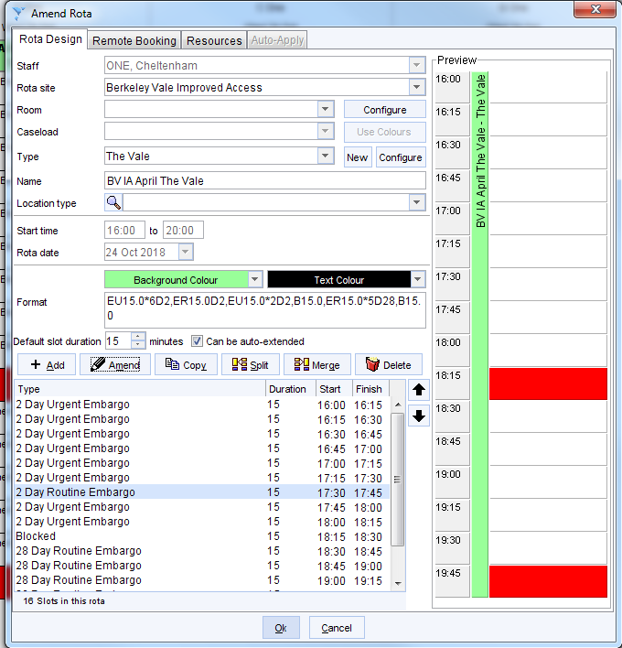

To DELETE the relevant session

Right click in the coloured
banner at the top of the session

Select “Delete” ()

Ensure you have selected the
relevant shift to delete

Click “Yes”

The session is then deleted

