IT System Unavailable - Processing Consultation Notes
Applicability: Countywide Improved Access Clinics
References:
- GDoc Countywide Improved Access Handbook - Appendix 1 What to do in the event of IT failure in a GDOC Improved Access Clinic - Policy for GPs

- Aim. This guidance is for GDoc administration staff and should be followed once an incident has been reported or GDoc becomes aware of an incident where the GP has conducted a Countywide Improved Access sessions and has been unable to access the SystmOne OOH module.

- Priorities. With a complete IT failure or a situation where the GP cannot access SystmOne, the work priorities are as follows:
- Ensure notes are send to patients registered practice
- Record notes retrospectively in the S1 OOH module
- Confirm patient sensitive data is removed from devices/systems
- SystmOne Housekeeping – Close any open cases

- Reference A provides instructions to GPs to cover 3 eventualities: a) Unable to access SystmOne but can use a computer with Internet access; b) Unable to use SystmOne but has access to a computer without Internet access; c) Unable to use a computer at all. In most circumstances we should be sent patient notes, so if we haven’t received anything during the first working day following the clinics, then contact either the GP or the hosting site to find out what has happened to them.

- These notes are most likely to arrive via email with Word or PDF attachments. Once we are content that all the documents have been safely received, we must contact the hub that hosted the clinic and ask them to delete the folders, files, emails, attachments or destroy any paper records they are holding.

- It is also possible that the hosting site may send us the completed paper consultation template. In whichever form they arrive, it is important that the notes are send to the patient’s registered practice. Use NHS mail with an attachment, one e-mail per patient. Send the e-mail to the patient’s registered practice with a request to confirm receipt of the Improved Access consultation. For audit purposes GDoc should only retain the e-mail confirmation from the practice.

- The consultation notes should retrospectively be recorded on the SystmOne OOH module against the patient record. See guide below on how to do this:

Retrieve the patient record, and then select Record Attachment
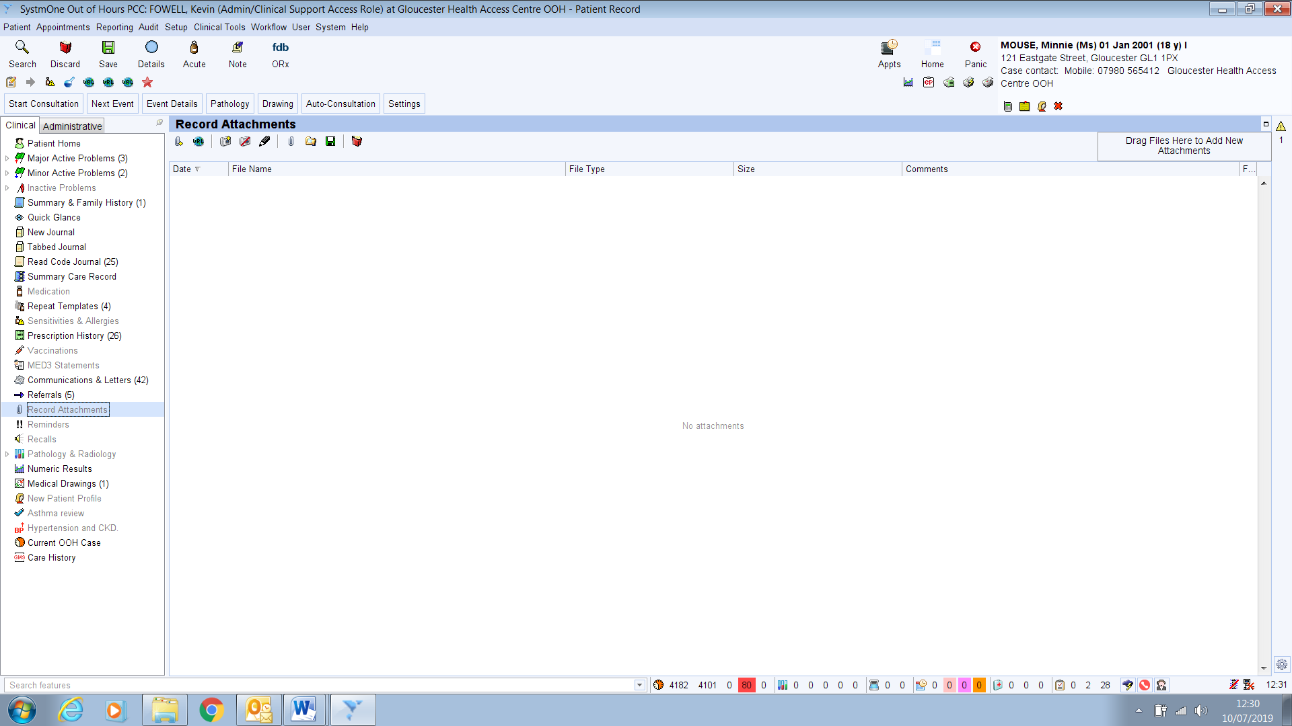
To attach the file containing the consultation notes you can; right click on Record Attachment in the Clinical List then Select Attach File: click on the Attach File icon: or drag and drop the file from your workstation. You can attach Word or PDF documents.
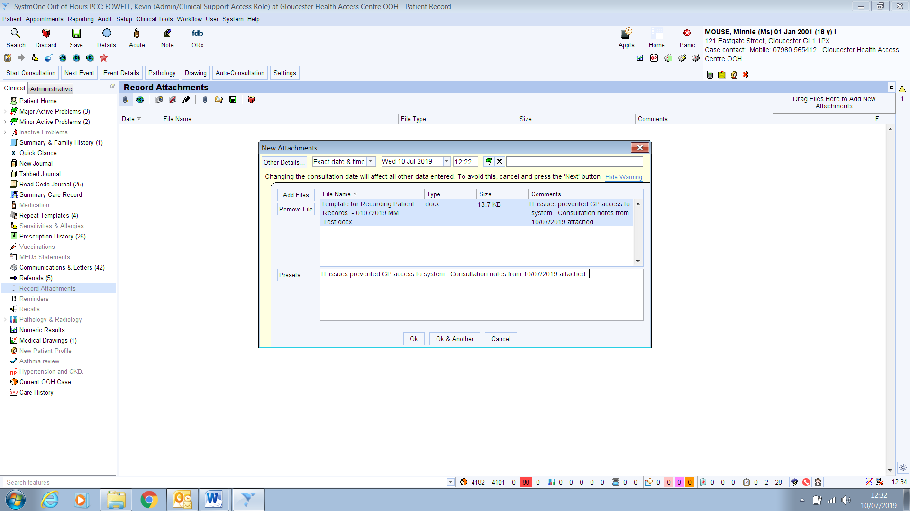
Now record an appropriate comment in the presets field on the New Attachments window and click OK.
You are then returned to the Record Attachment screen with the file you have just added associated with the patient record. 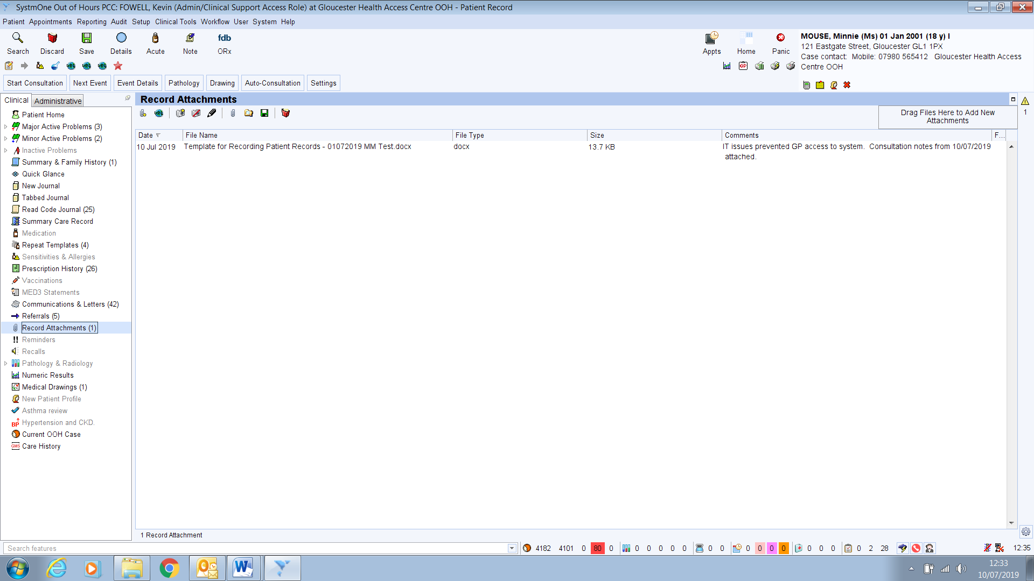

The action also generates a journey entry.
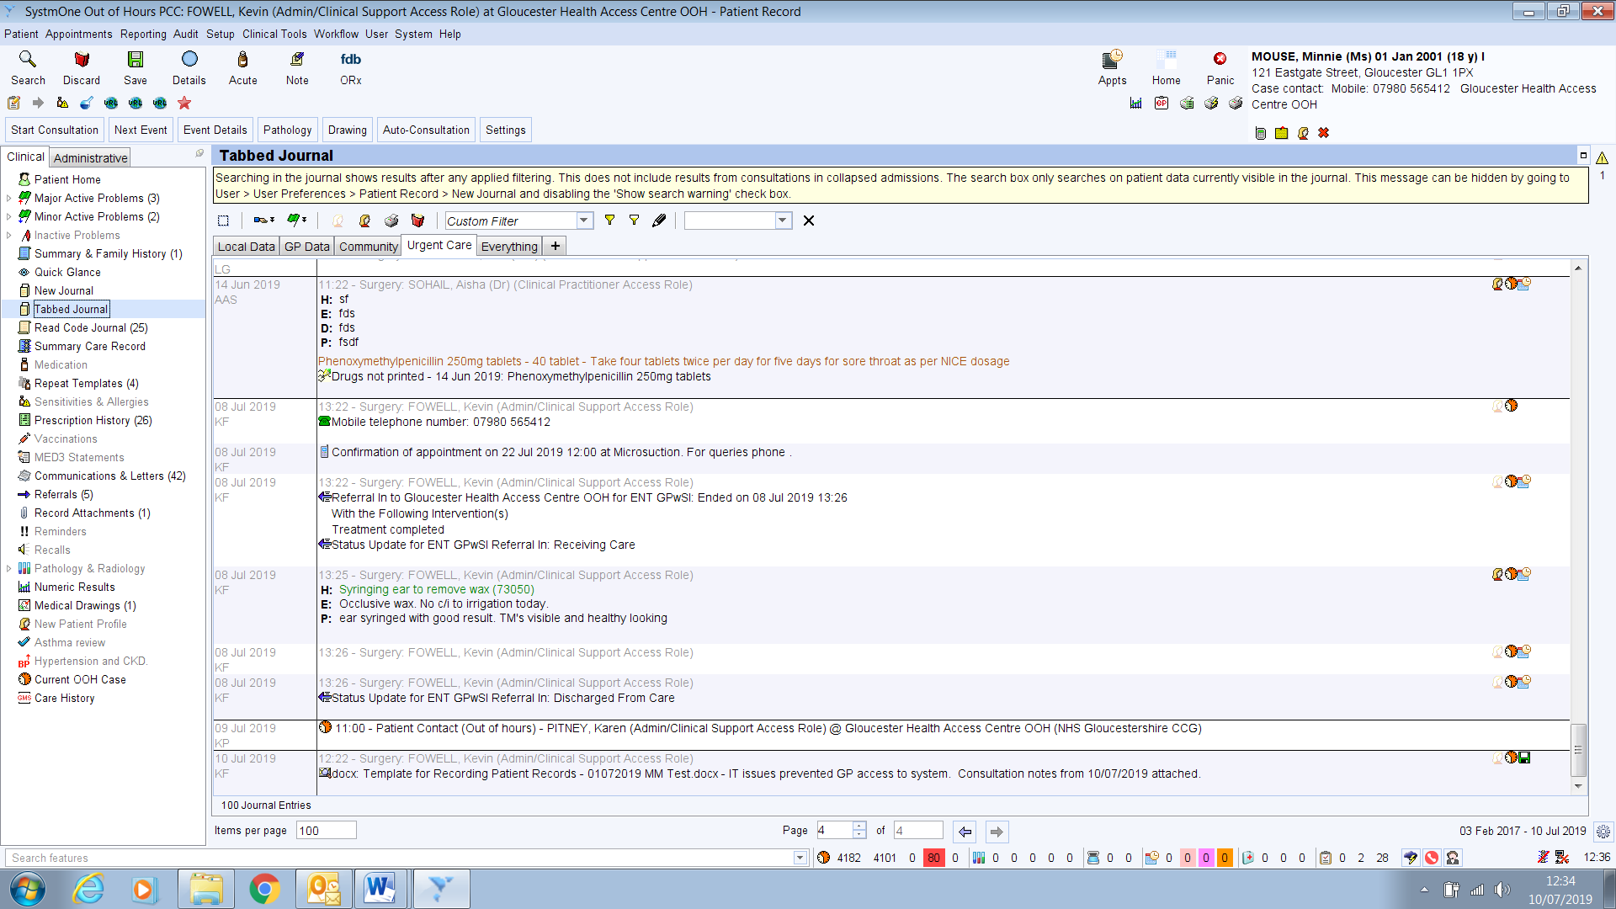
Finally, Save the record. At this point it would be appropriate to mark the appointment as finished. Back to the Appts screen, right click on the Appt and select Finished.
- Once the consultation notes have been safely stored on SystmOne, any emails, attachments and files must be deleted. Any paper containing the patient consultation notes must be disposed of by secure means. Remember to check both your workstation and memory sticks if you have been scanning documents. Also remember to empty your Recycle Bin to permanently delete files.

- Finally, check the appointment rota against the Open Cases Overview for any open cases. The state of the case will depend on the extent to which the system was affected. If there was a total system failure, it would be unlikely that any cases had been created. If only the GP access was affected, you could be left with open cases, which should be manually closed down. Add a comment to reflect “IT problems at Hub – notes e-mailed to practice”.

