Checking printer settings
Open a patient record and select the Medication Ribbon. Click the Config button.
The Medication Configuration window opens. Select Printer in Terminal options an configure the default printer.
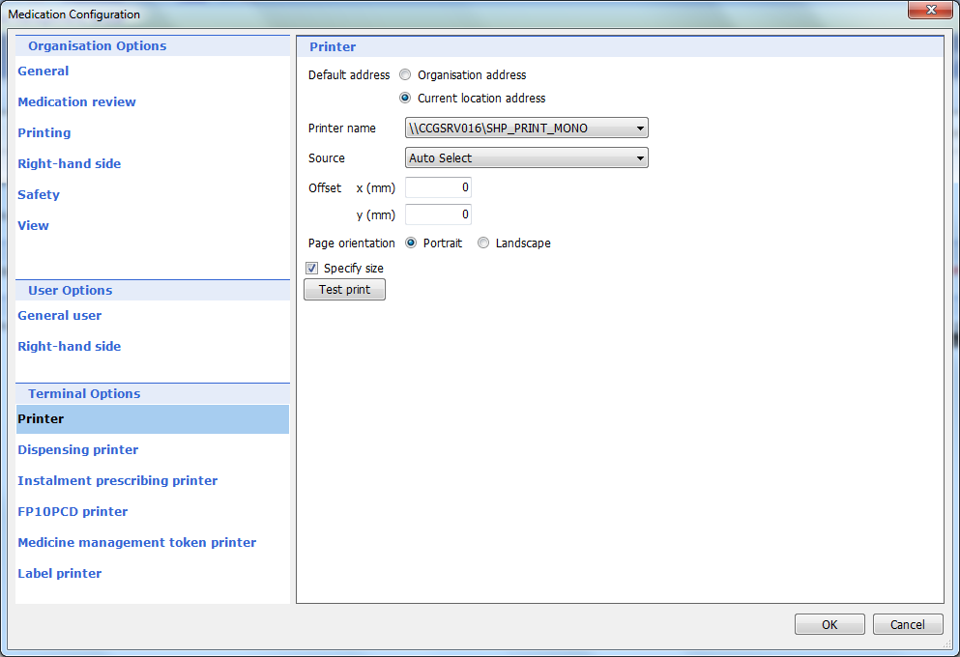
Re-print a prescription
Click the Emis Bubble and select System Tools from the menu. Select Prescription Printing.
The Prescription re-printing window opens. Select the prescription and click Reprint Selection.
