Textual Checking In Process for Choice+
- Log In - Log in to SystmOne OOH Module

- View Appointment Screen– View Appointment Screen for GHAC by selecting the appointments button on the top left and right. TIP - To amend sites that you can view use the drop down box on the bottom left

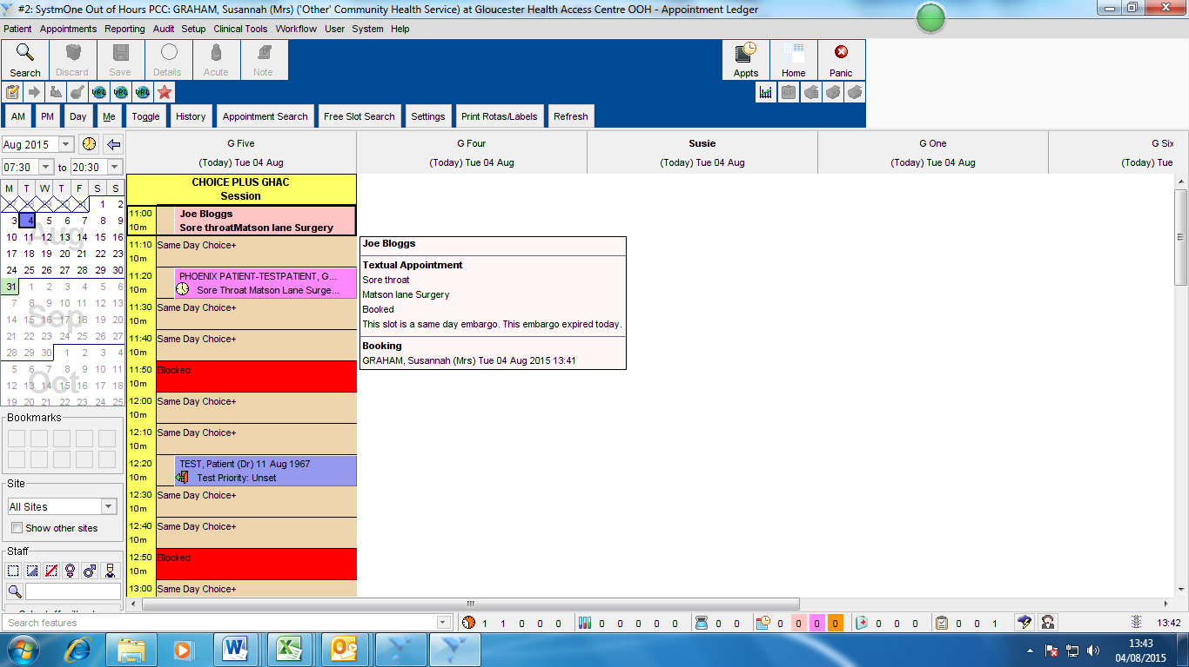
- Select the Textual Appointment – When the patient arrives to check in select their appointment by clicking on it. IMPORTANT - Textual appointments will be in lower case and will show as First Name, Surname, Problem, Referring Surgery (see example below)

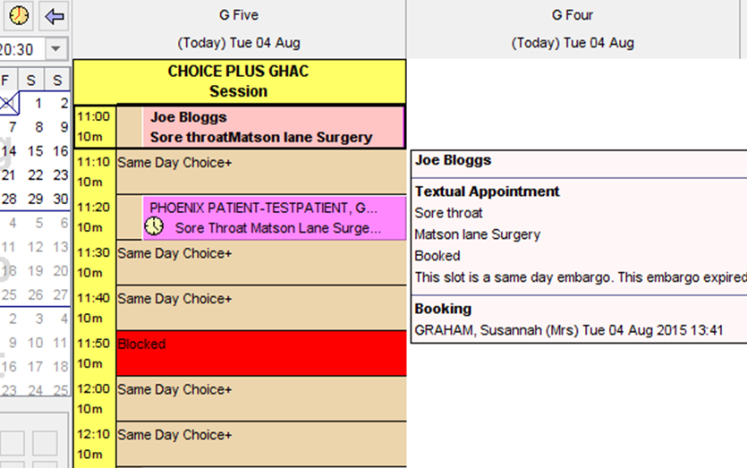

- Assign to patient – Right click – assign to patient
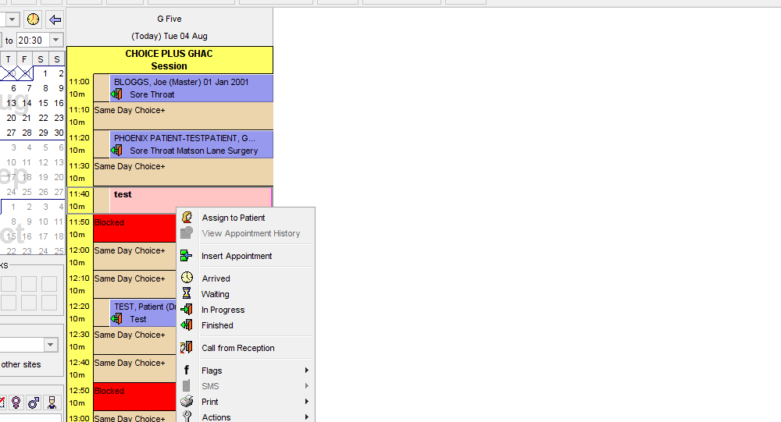

- Search for Patient – In the next screen search for the patient whose details you deleted form the appointment slot using – enter Patient Name, DOB and click on ‘Search’
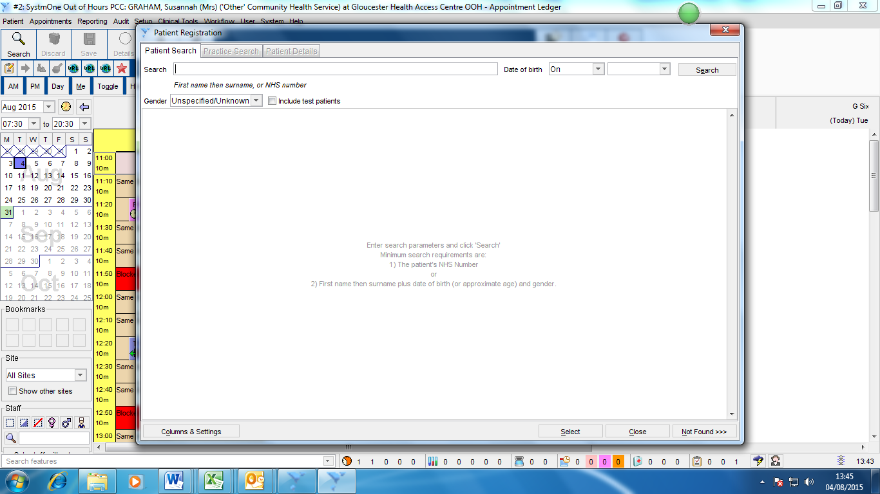

- Select patient – Choose the correct patient from the results and double click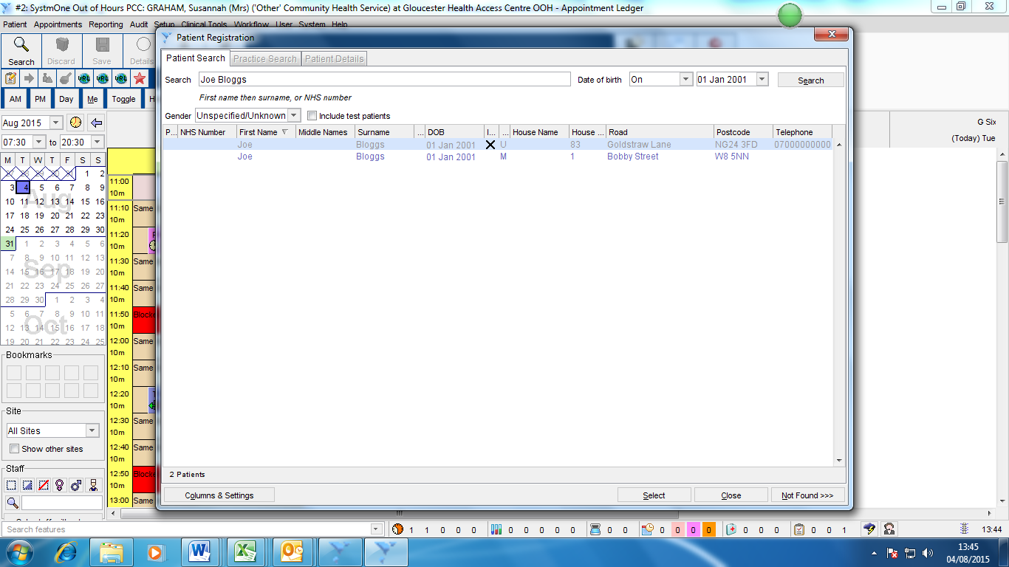
- Patient Consent – Check with patient their information sharing consent and record response - select OK
Sharing Out – Does the patient consent to sharing of the data recorded here with any other organisations including their own GP – If patient does not agree their GP will not be notified of this visit
Sharing In – Does the patient consent to the Doctor at this clinic viewing any data that has been recorded by other services that the patient has previously agreed to share e.g. Summary Care Records, Patient notes from a TPP site where patient has agreed to share out etc..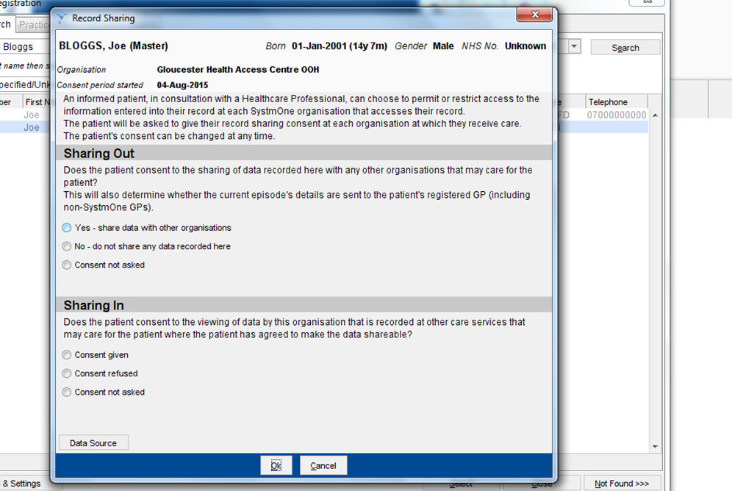

- Patient Details – In the patient screen check the patient name, dob, patient surgery (top right) TIP – to change or add surgery delete using the X and then search using the spy glass. If the patient isn’t registered with a practice leave blank.
Add patient Phone and number and check address – to change address click on the stamp on the left of the address box and run a postcode search. Select OK
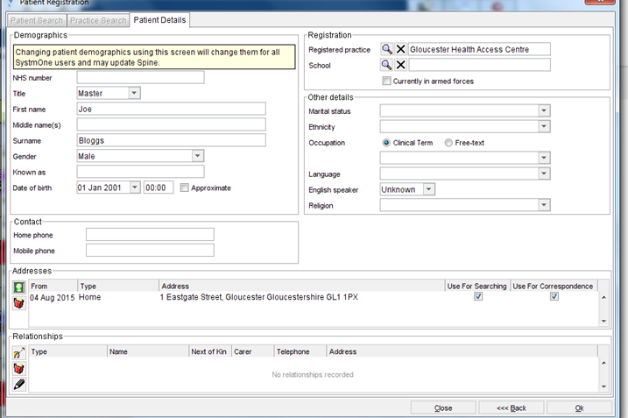

- Patient Illness – Enter Patients illness into the details box and select OK
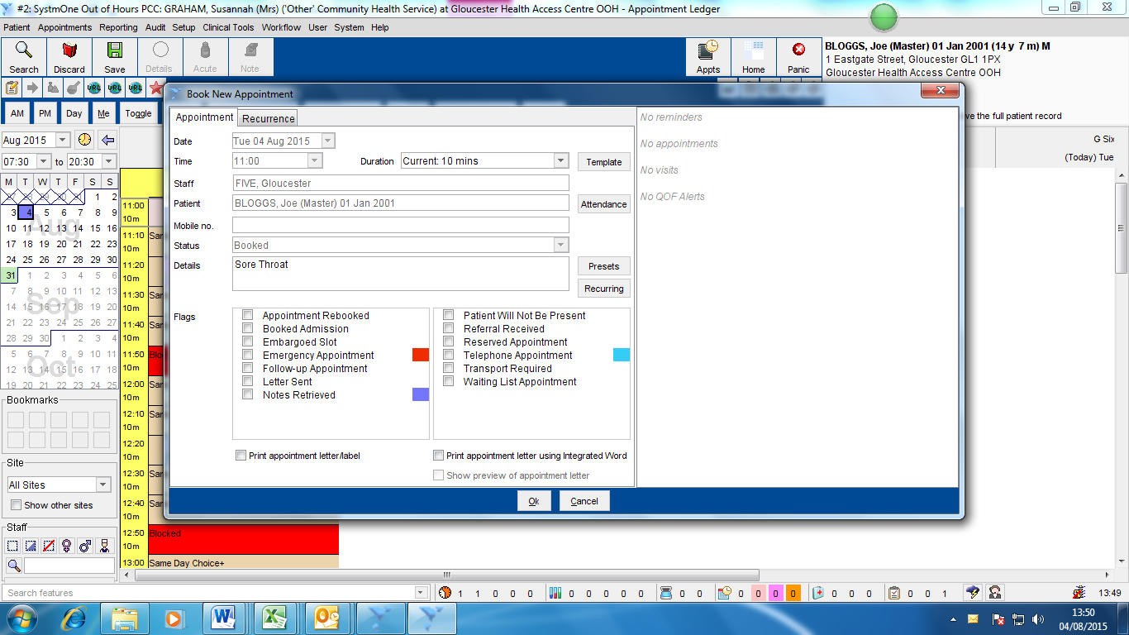

- Create Case – Click on Create Case & Link
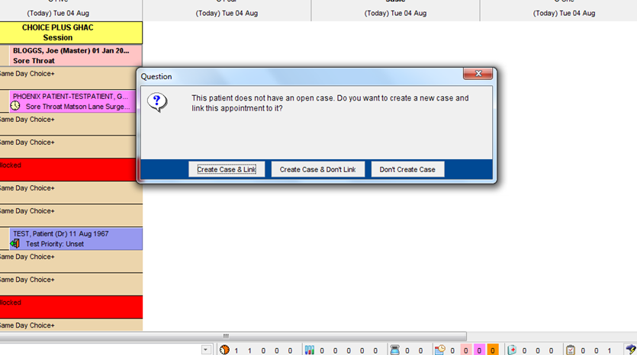
- Case Details- Click OK
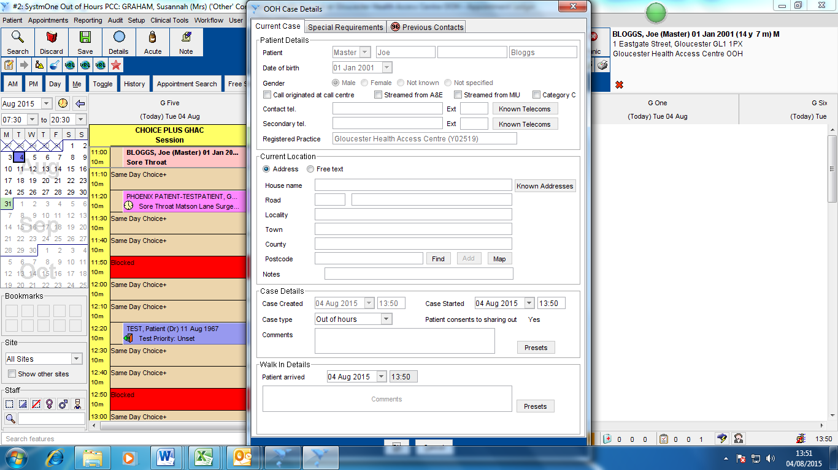

- Booking Summary – Select Close Window (top left)
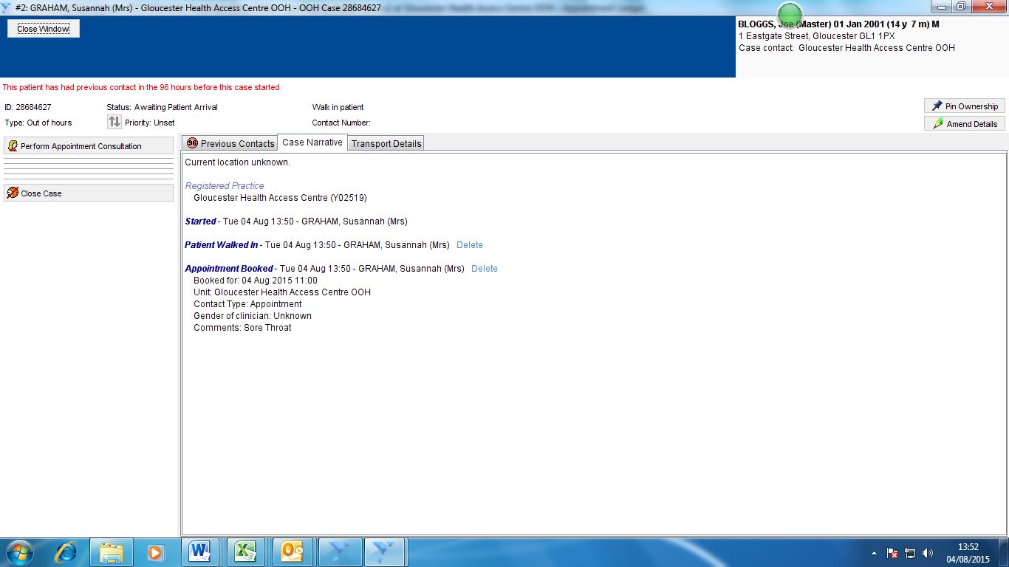

- Patient Arrived – Right click on the new booking you have created and select Arrived. The patient is now on the waiting list ready to be seen
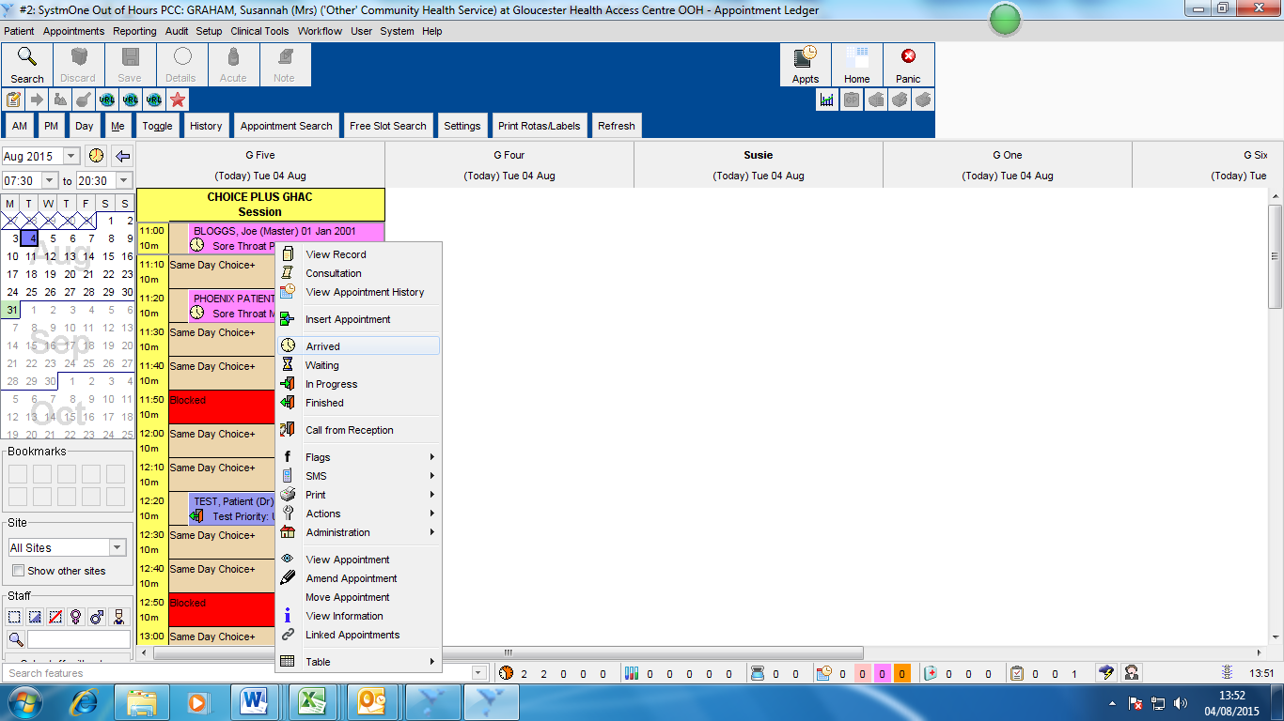

Walk IN & OOH Booking Process
- Follow the Textual Booking process starting at Step 4

