Remote Booking Patient Check In
- Log In - Log in to SystmOne OOH Module

- View Appointment Screen– View Appointment Screen for GHAC by selecting the appointments button on the top left and right. TIP - To amend sites that you can view use the drop down box on the bottom left

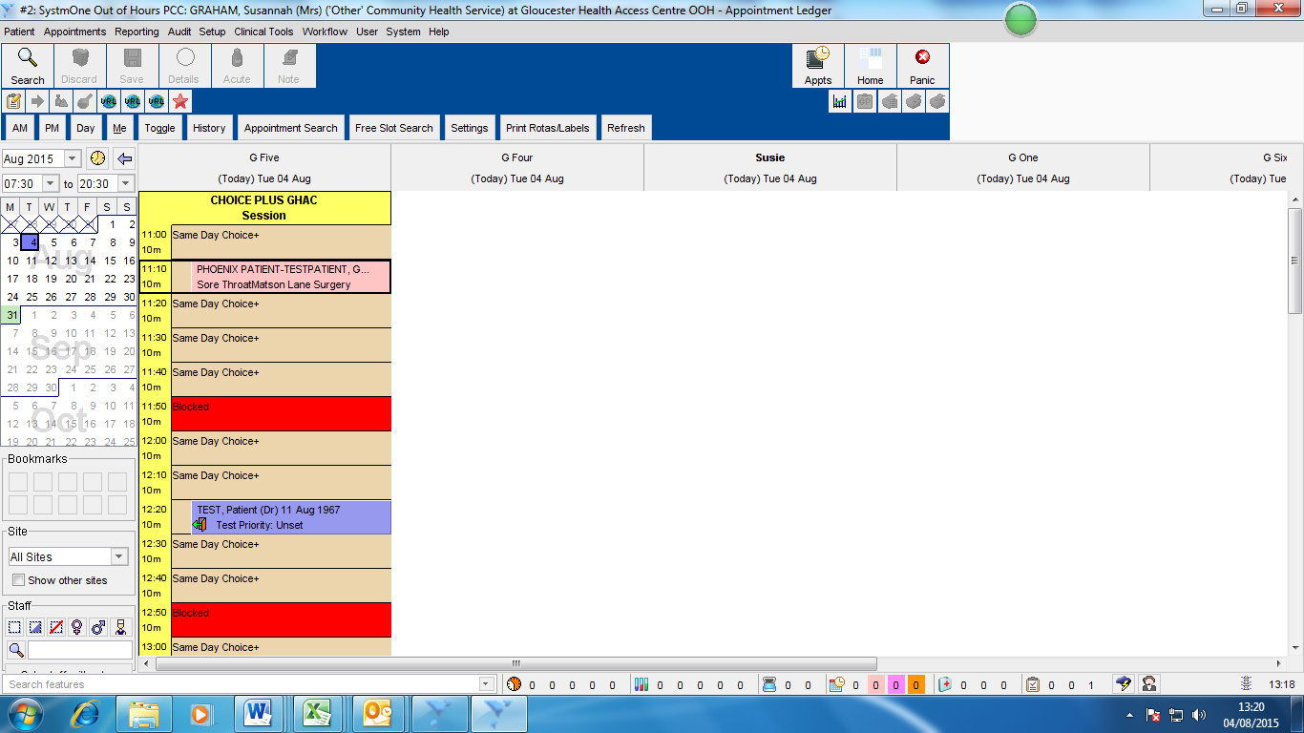

- Select the Remote Booking Appointment – When the patient arrives to check in select their appointment by clicking on it. IMPORTANT –
Remote Bookings will have the patient name in CAPITALS and be SURNAME, FIRST NAME.
Textual Bookings will be in lower case and be first name, surname.

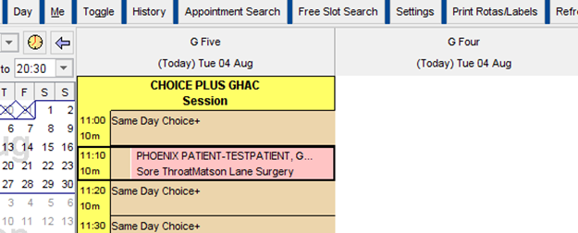
- View Record – Right click on Appointment and select View Record

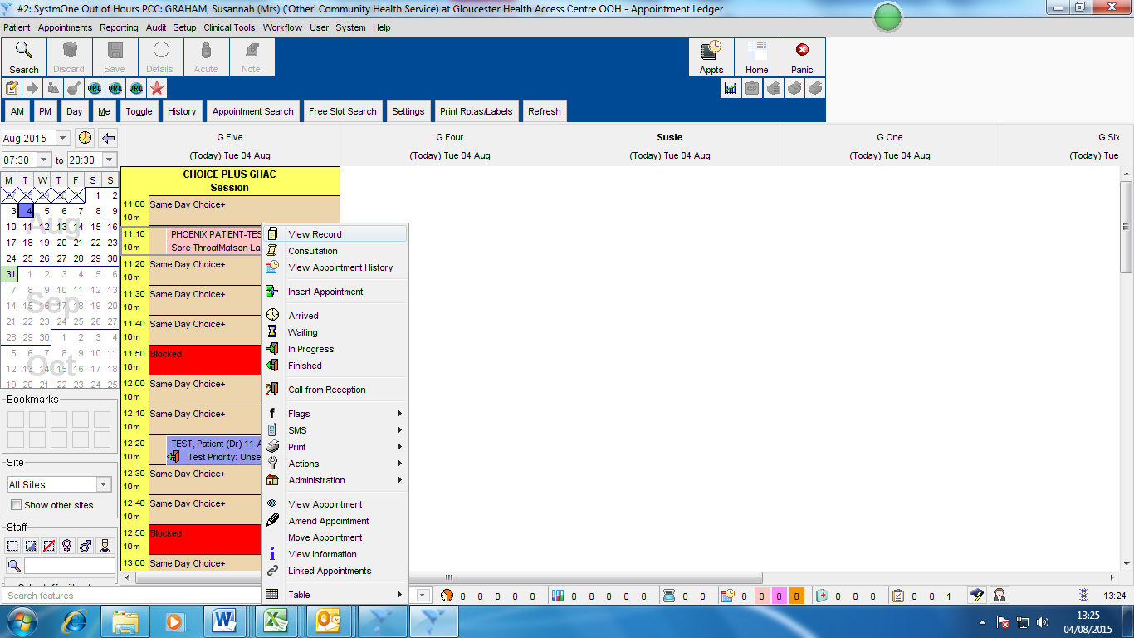

- Patient Consent – Check with patient their information sharing consent and record response - select OK
Sharing Out – Does the patient consent to sharing of the data recorded here with any other organisations including their own GP – If patient does not agree their GP will not be notified of this visit
Sharing In – Does the patient consent to the Doctor at this clinic viewing any data that has been recorded by other services that the patient has previously agreed to share e.g. Summary Care Records, Patient notes from a TPP site where patient has agreed to share out etc.. 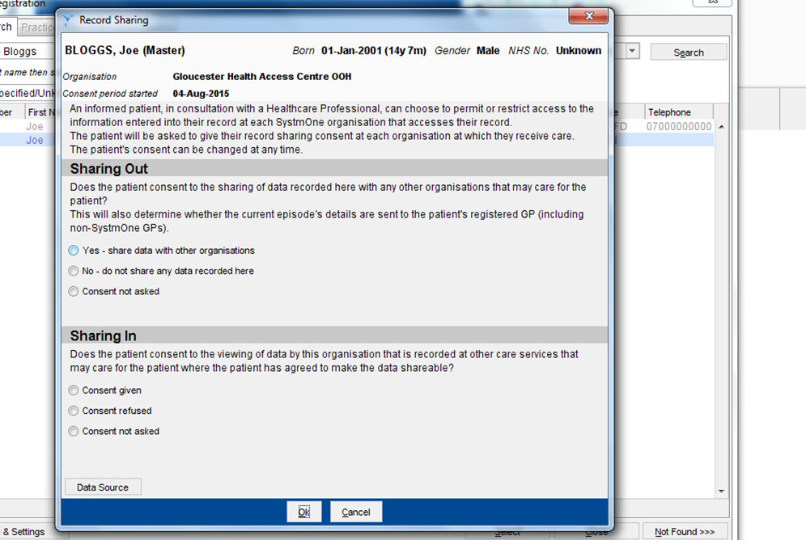
- Create Case – Click OK at the bottom of the screen.

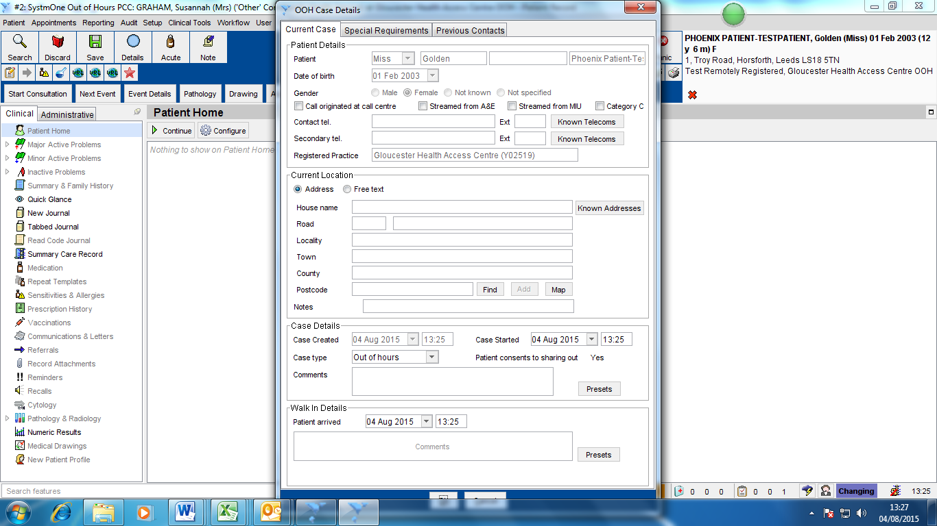

- Patient Home Screen –Save and close the next screen that appears using the Save button on the upper left

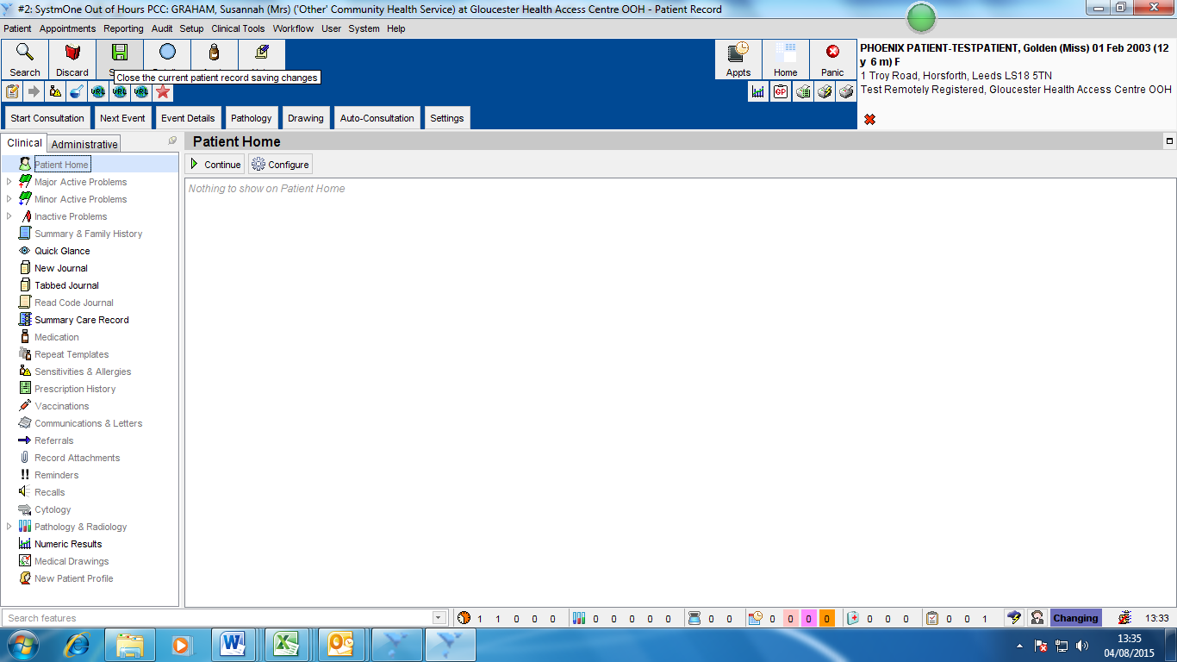

- Close Window – Close this screen by clicking Close Window button on top left

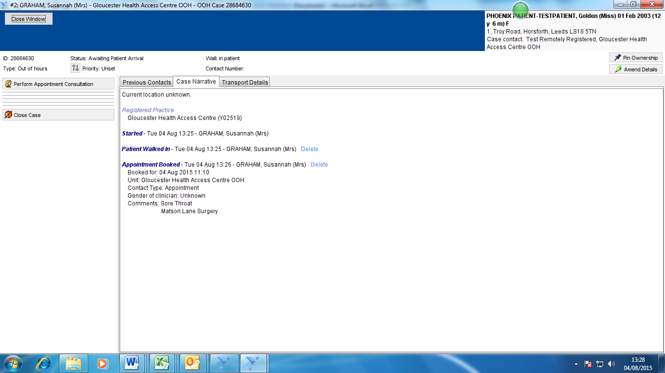

- Appointments Screen – select the Appts button the top right to take you back to the check in screen

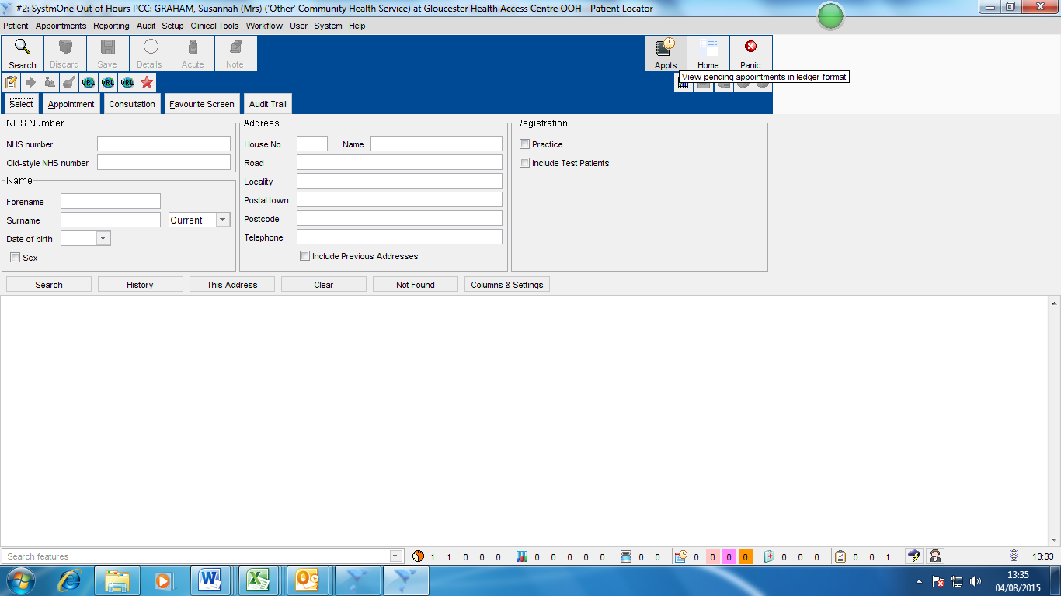

- Mark Patient Arrived – In the Appointments screen select the booking, right click and select Arrived. Patient is now ready to be seen by the GP

