Annex D - Completing a Patient Consultation on OOH SystmOne
- Log In - Log in to SystmOne OOH Module
FIRST TIME USE ONLY – Turn Off Automatic Read Coding
To ensure that consultations entered on the SystmOne OOH module do not adversely impact other SystmOne sites Patient notes where sharing in is enabled we ask all clinicians turn off the automatic read coding.
From the main screen select User from the top toolbar and then User Preferences from the drop down menu
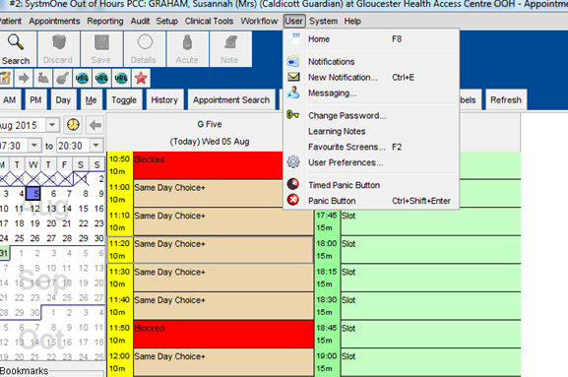
In the user Preference menu Click on Patient Records and then click on Consultation. Check that the ‘Enable automatic read code searching’ is NOT ticked, uncheck if needed. Click OK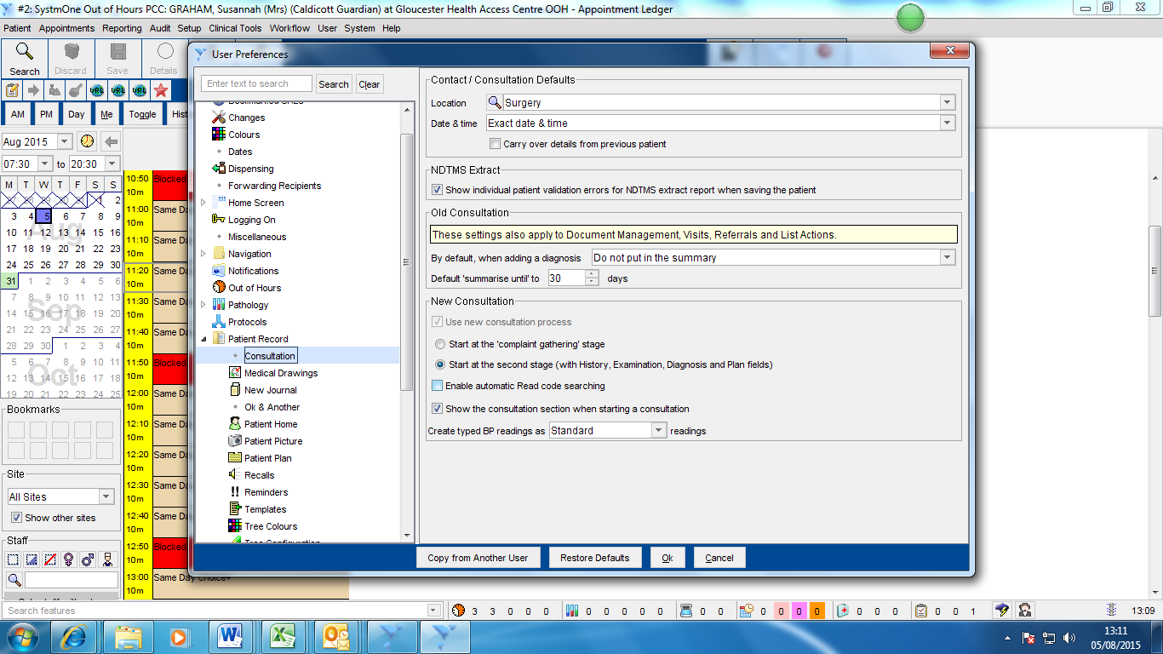

- Appointment Screen – From the home screen select the Appointment Button on the top right, this will show the booking screen

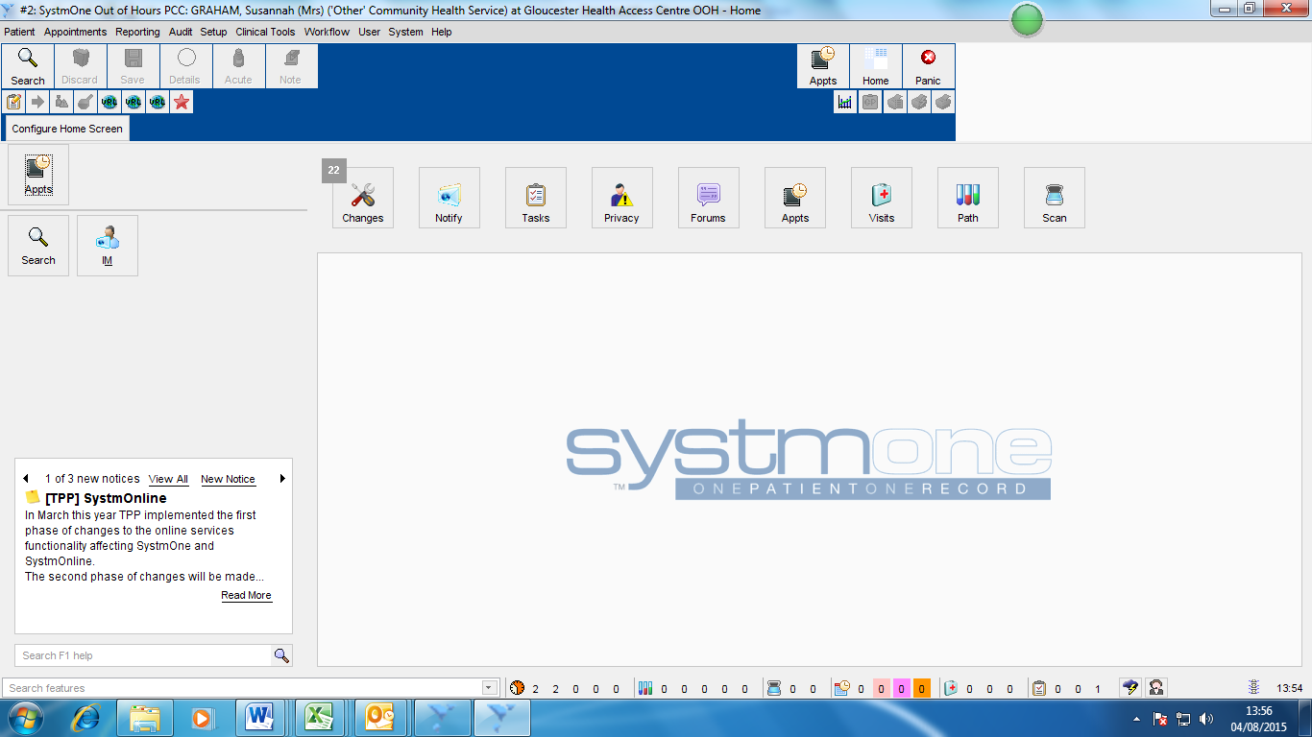

- Select Patient – Patients who have been checked in will show as a pink appointment with a clock. Right click on next patient to be seen and select Consultation.
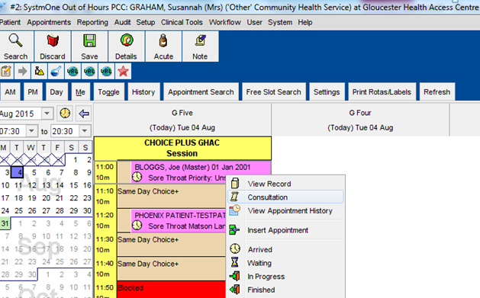
- Patient Screen – You will now be able to view the patient screen
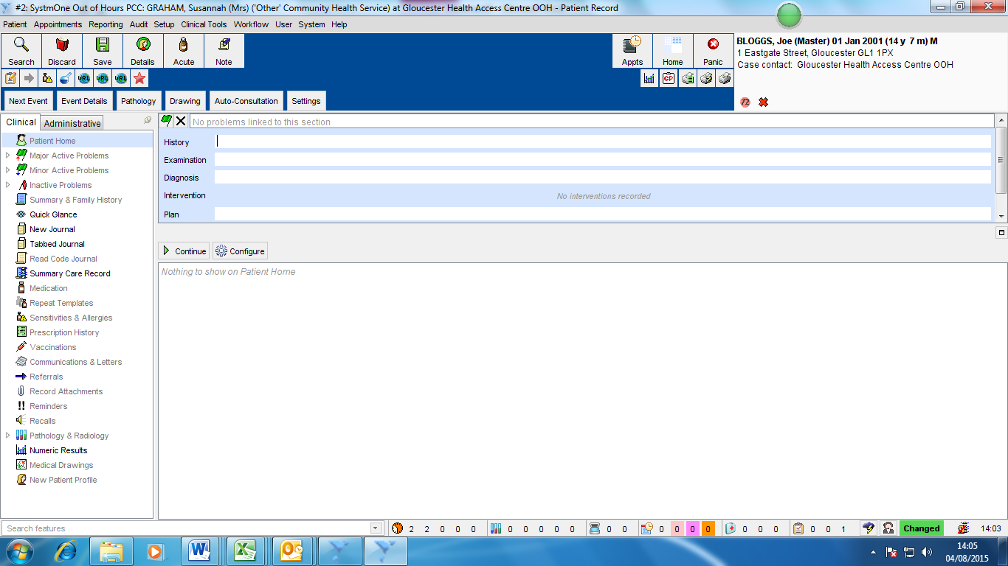
- Patient Records – If a patient has agreed to information sharing you will be able to view previous notes By selecting the New Journal or the Summary Care Record buttons on the left hand menu
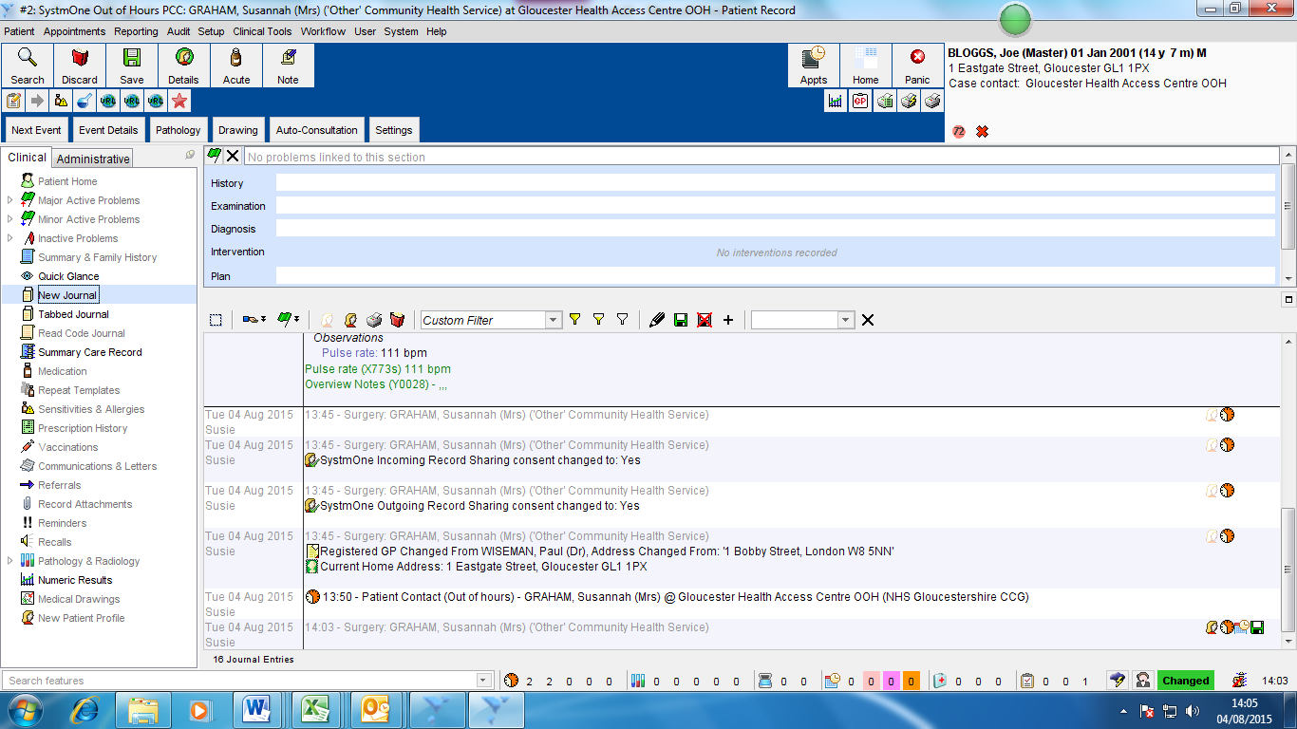
- Entering Patient Notes – Enter patient notes using free hand into the History, Examination and Diagnosis sections at the top of the page. IMPORTANT – Diagnosis will need to be entered manually as automatic coding has been disabled to prevent coding impacting patients home surgery records.
To Prescribe Acute select the Acute button on the top left.
To finish without prescribing click Save at top left and move to point 10.
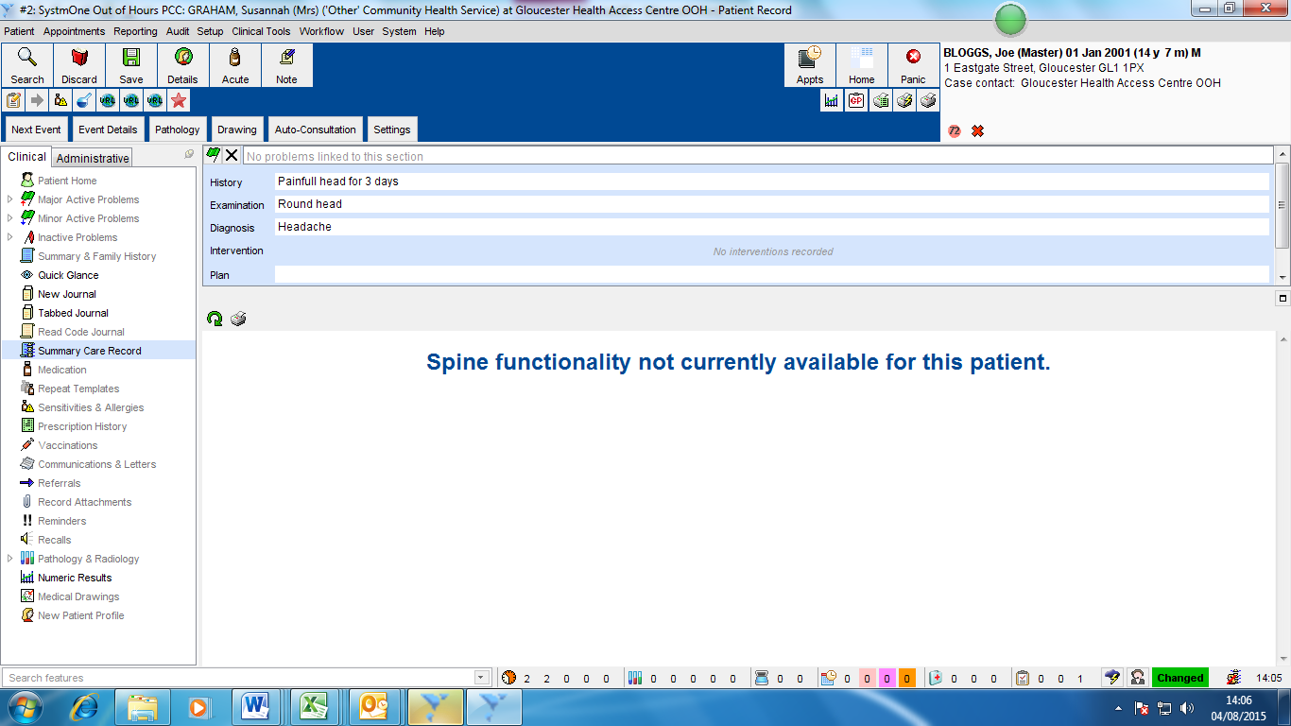
- Drug Selection – Search and select the required drug and click OK
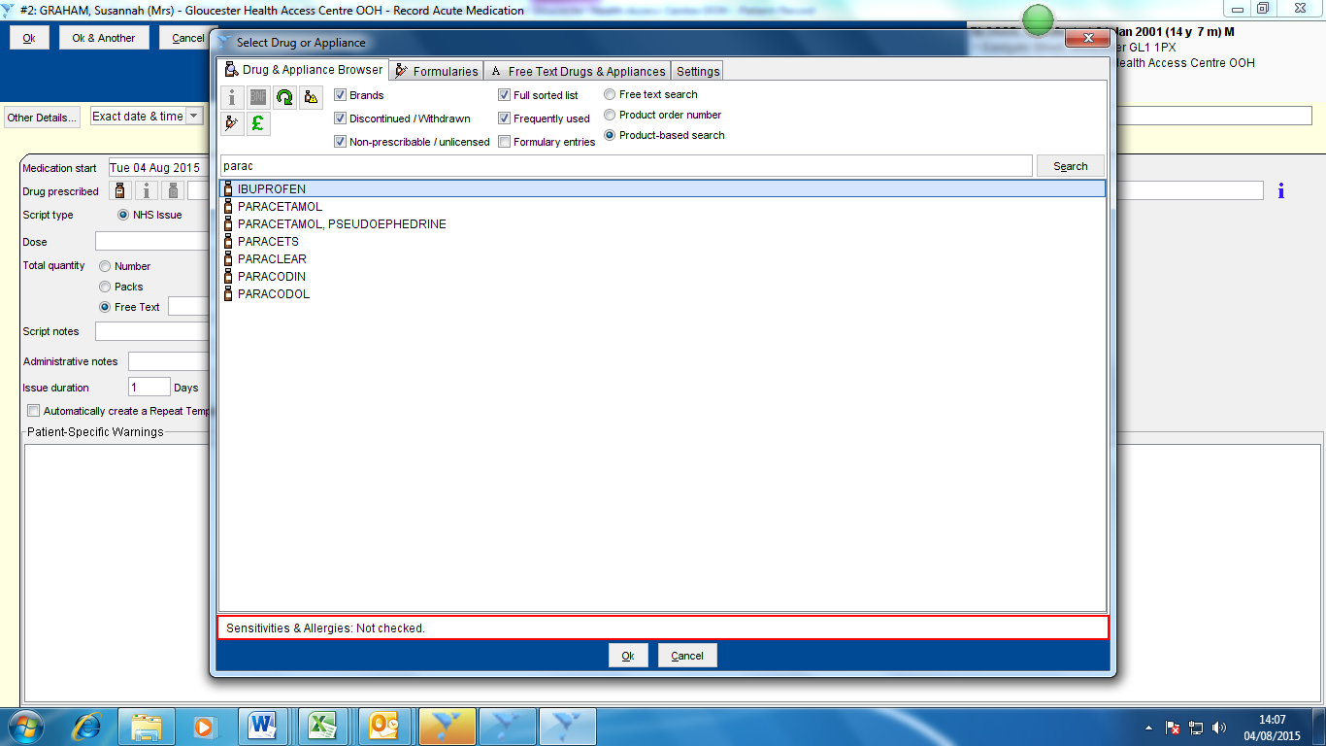

- Dose – Check Dose and amend information as needed. Once complete click OK at top left
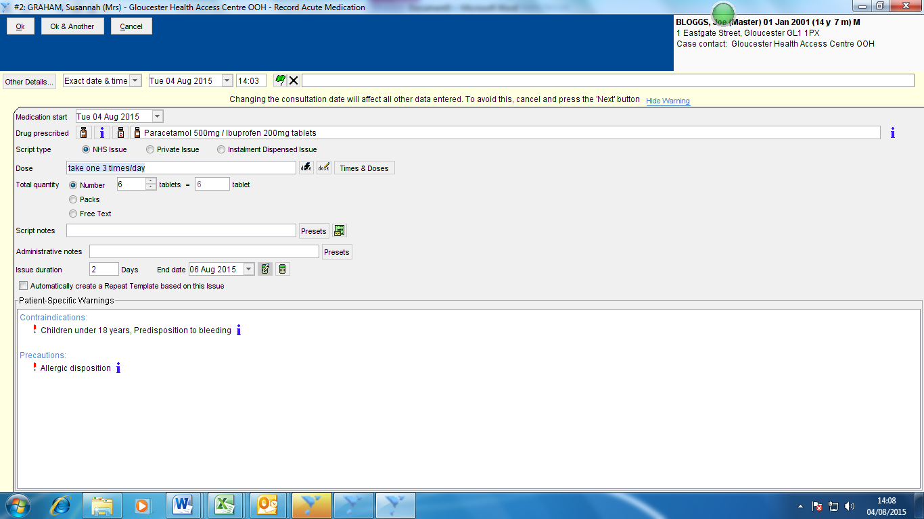
- Print Script - To print script immediately before you have completed entering notes click on the quick print button on the top right, complete entry of notes and click Save at top right. If you have finished notes and want to print click directly on save at top left and this will print the script.
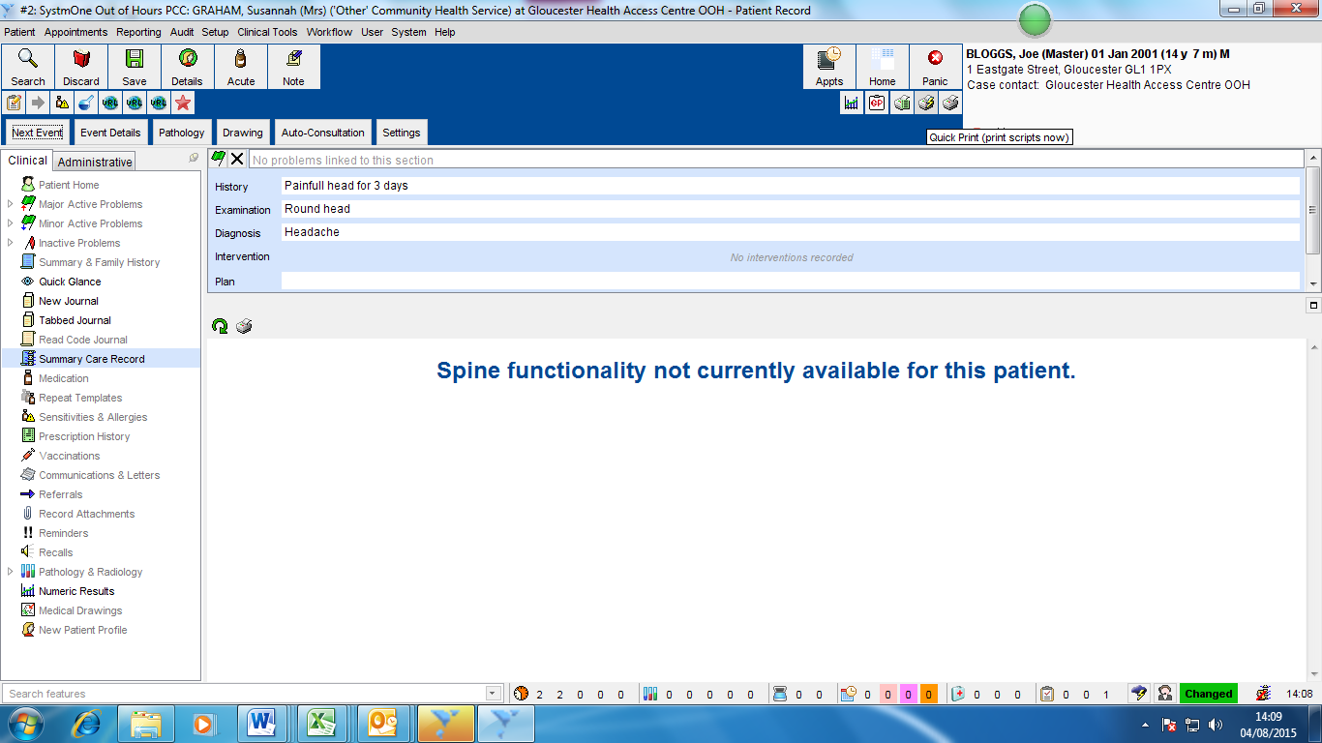

- Appointment Close – Click OK on the next pop up. If you receive an error message change the case started time to match the Appointment Booking start time and click OK
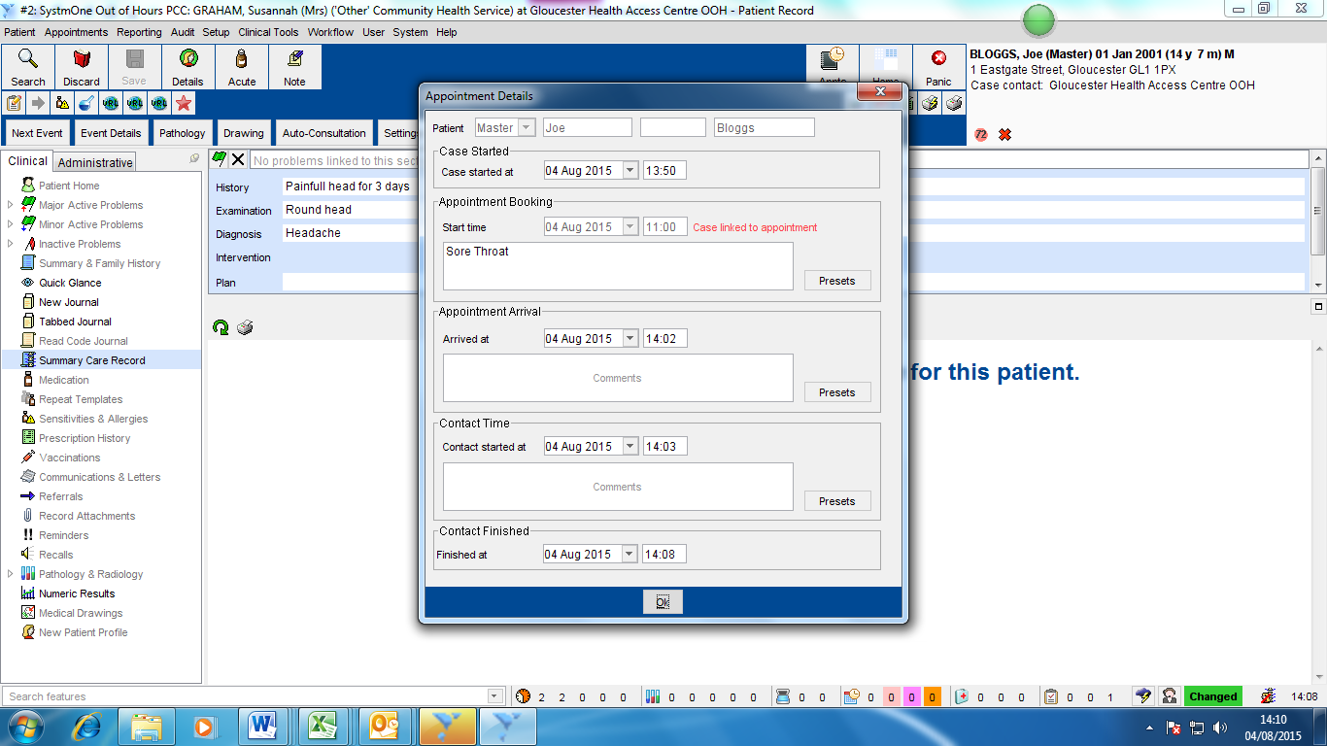

- Close Case – Click Close Case – to defer select Defer Decision and skip to point 13
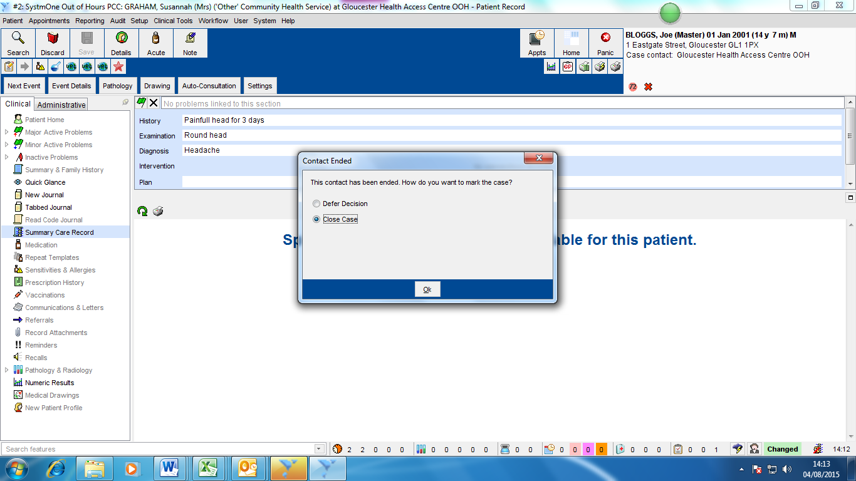

- Case Closure Details – Select the appropriate follow up actions and enter any comments if required. Click OK to close consultation.
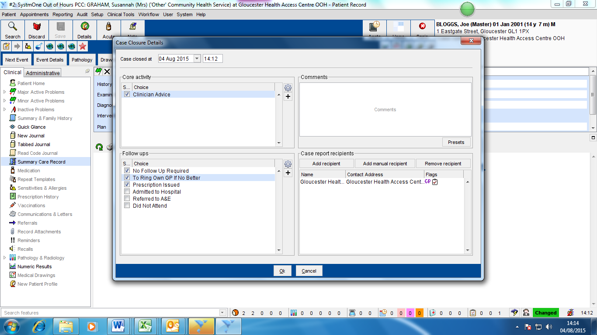
- Decision Deferred – If you select defer decision to close case, enter a reason in the comments box and click OK
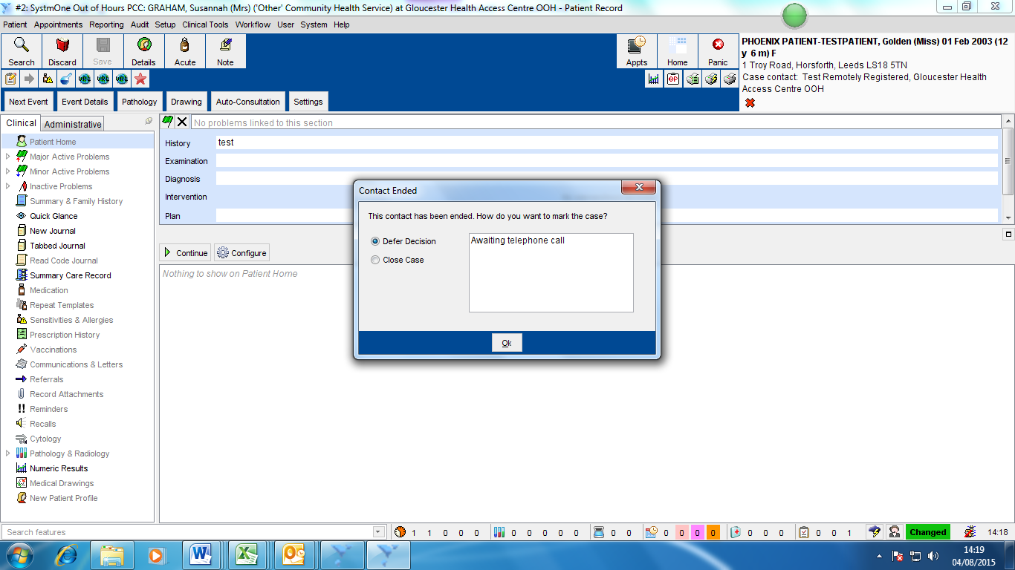
- Locate Decision Deferred Consultation - To access the decision deferred consultation click either right click on consultation in the appointments screen (point 3) (or click on the open cases at the bottom of the screen and select the correct patient from the list on the main screen.
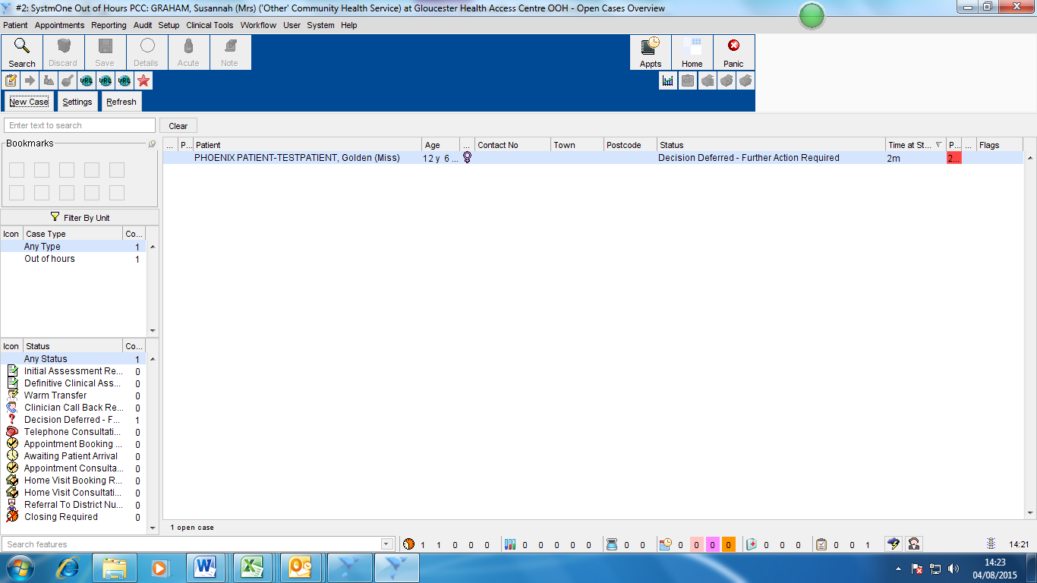

- Update Record – Update the patient record and enter additional patient consultation notes as needed. Refer pack to Point 6 to save notes and close case.

